Spellings Focus
Day 1:
LO: To find the etymology of words.
Etymology means the origin of the word e.g. from which ancient or modern language it originally came from.
Examples:
mobile: comes from the Latin word mobilis which means ‘moveable’.
marathon: comes from the story of a Greek hero, Pheidippides, who ran the 26 miles to Athens from the Plains of Marathon to tell of the Greek victory over the Persian army.
Challenge:
Can you find the origin/ etymology of some of these words?
adder bungalow genie limbo
salary vandal hamburger magazine
ketchup monster

Day 2:
LO: To look at the suffixes ‘ible’ & ‘able’
Points to remember:
- they sound very similar
- ‘able’ is more common than ‘ible’
- ‘able’ is used if there is a related word ending in ‘ation’

horrible | adorable | Additional words for days 4/5:
terrible | forgivable | incredible
possible | disposable | sensible
edible | enjoyable | reliable
reversible | valuable | respectable
invincible | breakable | agreeable
legible | identifiable | enviable

Challenge: Find the meaning of any unfamiliar words from the first two columns.
Day 3:
Create some word pyramids (remember from in class) to practise the most difficult spellings.
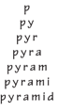

Day 4 (All of the columns of words):
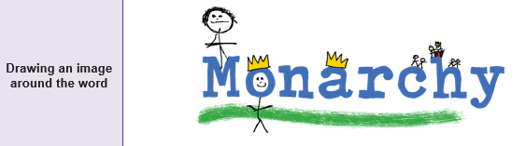
Day 5:
