Wednesday 14th October
Literacy
Today we will focussing on the story ‘The Giant Turnip.’ Please use the link below to complete lesson 1 – to listen and join in with a story.
https://classroom.thenational.academy/units/the-giant-turnip-79c6
After that, I would like you to make a story map to help you retell the story. You can watch lesson 2 – to map and speak the story, to help you create your story map.
Remember you can email any completed work to reception@moornook.lancs.sch.uk.

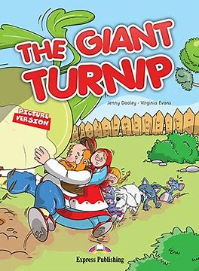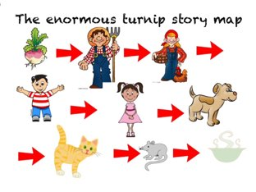
Today would have been ‘baking day.’ Today can you make some crispy cakes? What are instructions? Can you follow the instructions below to make your crispy cakes? Get your child to help you with measuring the ingredients out. You can choose a different baking recipe if you wish.
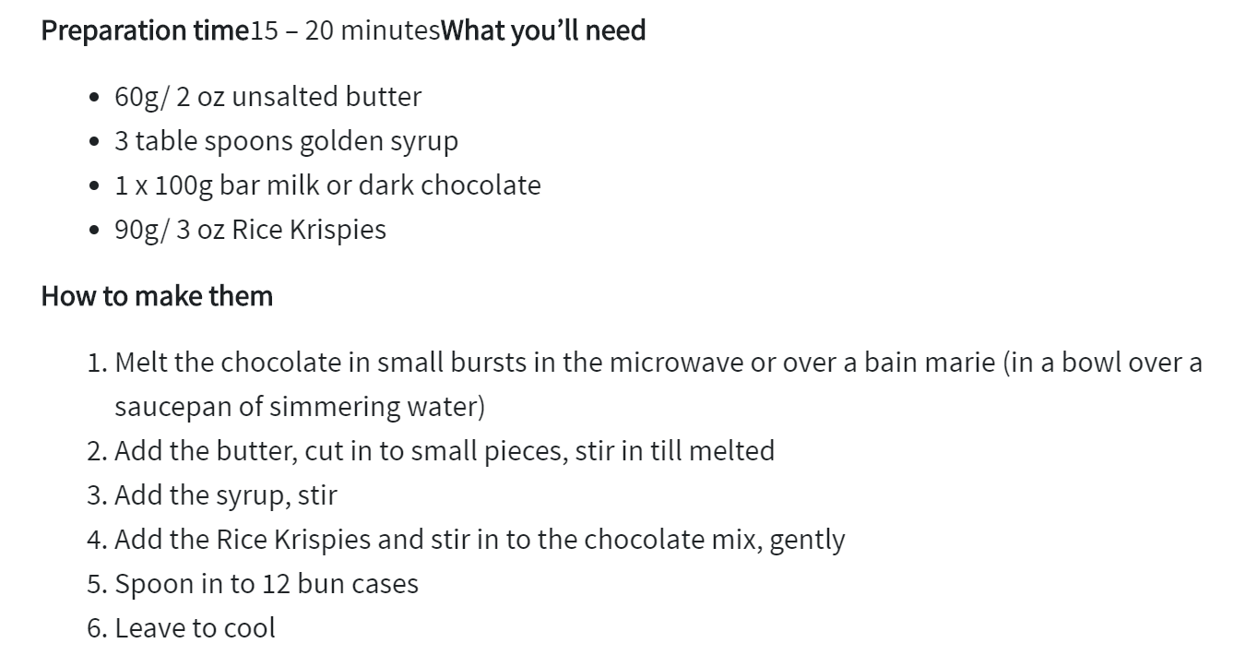
Don’t forget to practise writing your name every day! This week’s spellings are on the website.
Phonics activity | Number activity | Shape activity
Letter of the day – o  The action to this sound can be found on youtube – if you search jolly phonics phase 2 song.  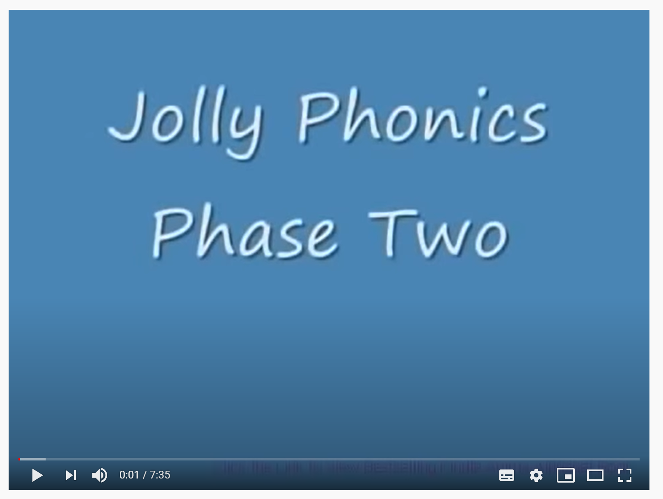  Today’s activity is – go on a sound hunt. Hide the sounds listed below on pieces of paper around the house.  s a t p i  n m d g o  Can you make some words using the sounds you found? | The Number of the week is 4.  Today’s activity is -subtracting –  Can you solve the number sentences below?  3-2=  4-2=  4-1=  4-3=  You can use your fingers to help you or count objects and then take the amount away and find out how many are left. | What is this shape?  Can you find this shape around your house?  How many sides does this shape have?  Practise drawing this shape.

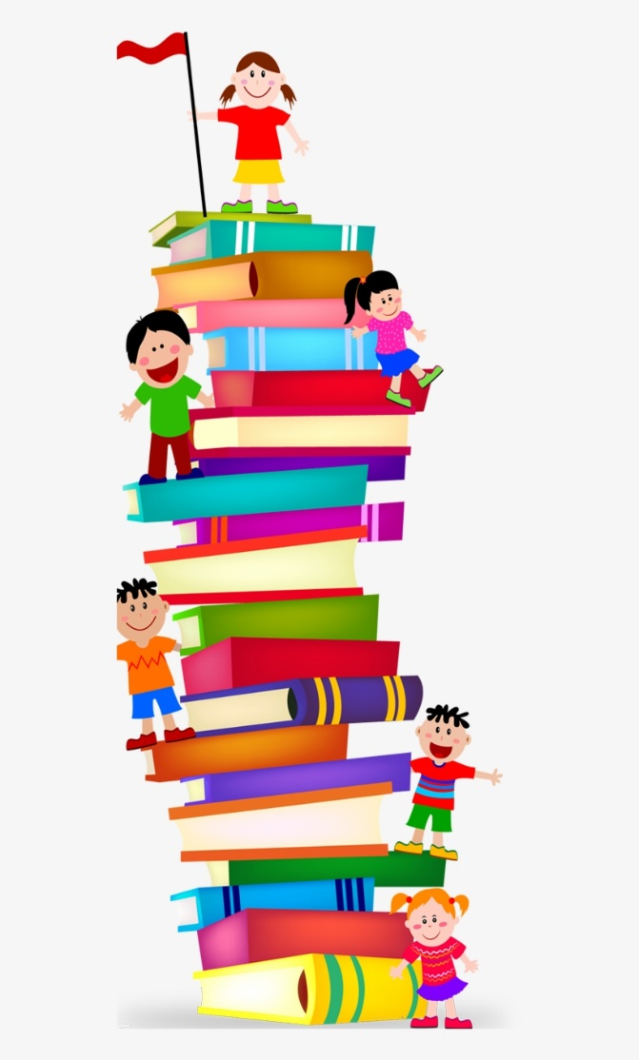
Story time – Read your favourite story at home with an adult or listen to my favourite story being read on YouTube. Just search ‘The Gruffalo.’

Now answer the following questions –
Who are the characters in the story?
Can you describe your favourite character?
What happened in the beginning of the story?
What happened at the end of the story?
Look at the setting – Where do you think the characters are?

Asking questions when reading a story really supports your child’s understanding.
Happy reading!

