Weekly Maths Planning Sheet Week Beg: 19/10/20 |  | Focus:  Arithmetic focus Division | Key Vocab:  calculate mentally formal method column method integer decimal add, plus, sum, total subtract, take away, difference multiply, product represent estimate round approximate formula term
Learning Objectives | Main Teaching | Representing  (Showing) | Fluency  (Practising) | Probing Questions  (Explaining) | Rich and Complex Tasks (Solving)
- Divide a 3/4-digit number by a 1-digit number using a written method  X2 sessions for some | What is dividing?  What is meant by the term divide?  How can we explain what we are doing to a number when we are dividing?  Recap the bus stop method – most will have done this in year 5 - using the interactive whiteboard model 3 and 4 digit numbers divided by 1.  Model  - no exchange necessary e.g. $9366 ÷3$  - first digit is lower than divisor requiring exchange e.g. $2196 ÷3$  - single exchange e.g. $2376 ÷3$ or $8476 ÷4$  - two or more exchanges e.g. $4185 ÷5$  - examples with remainders e.g. $4189 ÷5$ |  | Same progression as modelled set of division calculations  8842 ÷ 2  3248 ÷ 4  5766 ÷ 6  2877 ÷ 3  8476 ÷ 4  4185 ÷ 5  4279 ÷ 5  9759 ÷ 7  Over into a second session due to inaccuracy  9366 ÷ 3  4848 ÷ 4  2196 ÷ 3  4505 ÷ 5  2376 ÷ 3  6472 ÷ 8  3792 ÷ 4  9856 ÷ 8  4189 ÷ 5  7399 ÷ 4  LA – working on dividing by 2, 3 and 5  Sharing with the use of objects | Convince me 1756 ÷ 5 will have a remainder of 1
- Divide a 3-digit number by 2-digit number using a formal written method | Model  - known times table, no remainder e.g. $756 ÷12$  - simple times table to derive, no remainder e.g. $966 ÷21$  - larger number requiring derivation of times table, no remainder $986 ÷34$  - examples with remainders e.g. $874 ÷15$ |  | Same progression as modelled set of division calculations  Have divisions within the 12 x table in case  920 ÷ 10  612 ÷ 12  864 ÷ 24  945 ÷ 21  468 ÷ 36  672 ÷ 42  864 ÷ 15  923 ÷ 23  328 ÷ 32  LA – working on dividing by 2, 3 and 5  Sharing with remainders | Convince me 598 ÷ 26 = 23
- Divide a 4-digit number by a 2-digit number using a formal written method  X2 sessions needed | Model  - known times table, no remainder e.g. $2856 ÷12$  - simple times table to derive, no remainder e.g. $6594 ÷21$  - larger number requiring derivation of times table, no remainder 3591$÷57$  - examples with remainders e.g. $4588 ÷16$  Taking two sessions |  | Some children staying within their times tables, so they are still dividing using the formal method  1 140 ÷ 12  1 188 ÷ 12  1 320 ÷ 12  2 136 ÷ 12  3 568 ÷ 12  4 738 ÷ 12  9 635 ÷ 12  Majority – those accurate with x12 to progress to these calculations  1 140 ÷ 12  1 001 ÷ 11  1 365 ÷ 21  1 056 ÷ 22  1 120 ÷ 14  4 788 ÷ 57  3 366 ÷ 34  5 269 ÷ 27  6 917 ÷ 46  9 308 ÷ 25  LA – working on dividing by 2, 3 and 5  Bus stop method | Convince me that $6279 ÷23=273$  Always, Sometimes, Never?  Long division is needed to divide a four digit number by a two digit number
- Divide a 4-digit number by a 2-digit number using a formal written method giving the remainder as a fraction | Continue after half term  - known times table, no remainder e.g. $2857 ÷12$  - simple times table to derive, no remainder e.g. $6597 ÷21$  - larger number requiring derivation of times table, no remainder 3541$÷57$ | Using place value counters to complete the division practically. When the final remaining units are separated, using bar to represent how much of a full divisor they are. When dividing by 12 and having a remaining 5 ones, this represents or 5/12 of a whole column | 4637 ÷ 12  2398 ÷ 12  5437 ÷ 12  3928 ÷ 12  1965 ÷ 21  2130 ÷ 29  9822 ÷ 34 | Convince me that if I divide 132 sweets between 5 people, this gives 26 r2 or 26 2/5 each.
- Divide a 4-digit number by a 2-digit number, giving an answer to up to 2dp, using a formal written method | Divide a 4-digit number by a 2-digit number, giving an answer to up to 2dp, using a formal written method  - example resulting in exactly 1dp e.g. $4580 ÷16$  - example resulting in exactly 2dp e.g. $4576 ÷16$  - example resulting in longer decimal (requiring truncation) e.g. $4579÷16$ |  | Answer to one decimal place  3928 ÷ 11  1965 ÷ 23  Answer to two decimal places  2130 ÷ 29  9822 ÷ 34  9144 ÷ 29 | Convince me that $6143÷11=558.45$to 2 decimal places.
- Recognise and solve a simple division problem, interpreting any remainders in the context as appropriate. | Using the bar model to represent a word or other division problem. For example:  6 people share £1764 equally between them. How much do they each receive?  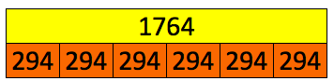 | Keeping with the use of bar models  Remainder problems – an account has £9542 in it. If you spend £86 per day, after how many days will the money run out?  word problem – sharing language e.g. 3282g flour to make 56 cupcakes. How much flour is in each cupcake?  word problem – grouping language e.g. 2543 people go to Wembley. 52 people can fit on each bus. What is the minimum number of buses required? | 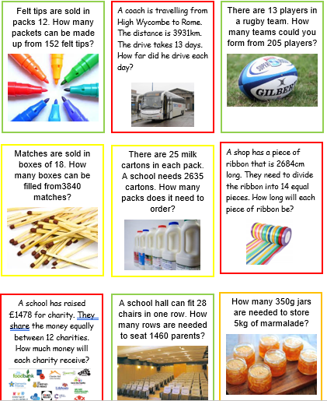  Making the decision whether the remainder needs to be rounded up, done, expressed as a fraction or a decimal | Convince me that a remainder of 5 can mean different things in different questions

