Home Learning 11/11/2020 -18/11/2020

Maths
This week in maths we have been looking at addition and subtraction. Over the next week I would like you to attempt these questions. These questions are the same question the children in school have been attempting. Enjoy!
Lesson 1
1571+1329=
6534+2329=
5293+1425=
3945+2323=
4562+1579=
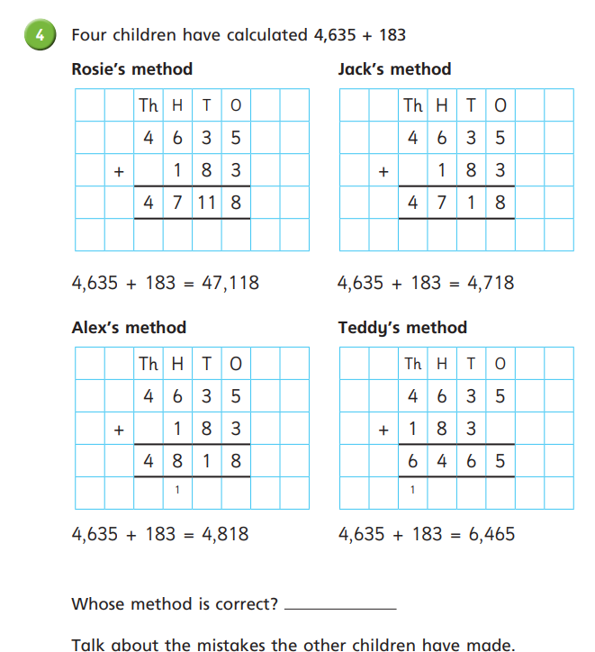
Lesson 2
8957-10=
6793-10=
7896-10=
3248-100=
4745-100=
6728-1000=
9345-4000=

Show me two numbers with a difference of 2000.

Always, Sometimes, Never?
Subtraction makes a number smaller.

Lesson 3

7635-122=
1351-222=
3417-125=
9821-435=
3782-931=
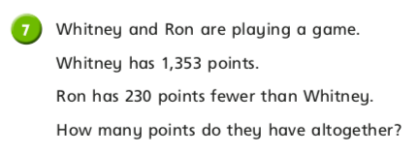

Lesson 4
5675 – 3254=
5675 – 2359=
5675 – 3281=
5675 – 2886=

Show me
... two numbers that are easy to subtract
... two numbers that are hard to subtract.

Always, Sometimes, Never?
A four digit number subtract a four digit number gives a three digit number.

What’s the same and what’s different?
2285 + 3126;
3126 + 2285;
5411 – 2285;
5411 – 3126
3126 – 2285
2285 + 5411
3126 + 5411
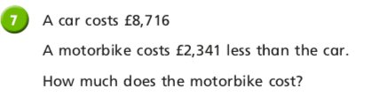

English
In class this week we have been rewriting a familiar story. We have watched this short story.
https://www.youtube.com/watch?v=m9tQYBf4-hg&safe=active

Your task is to change the characters and the problems faced by the Loch Ness Monster and rewrite the story. Use the plan below to help you create your ideas. Once you have planned your new story you will then need to rewrite the story.
 | New Idea | Any Extra Information
Characters
Setting
Nessie’s Problem

