Thursday 15th October
Today we will be learning about ‘Friendships’ This is our school value for this half term. Talk to your adult about who your friends are in school and out of school? What makes a good friend? Have a look at the list below of what qualities make a good friend. Choose one of the activities below to complete.
Draw a picture of you and your friend. | Make a card for your friend.
Make a list of things you like to do with your friend. | Draw a picture for your friend.
Tricky words
Listen to the tricky word song using the link . https://www.youtube.com/watch?v=TvMyssfAUx0
Can you write the tricky words and practise reading them. You could play tricky word bingo with an adult once you have written them.
I | no | go
to | the | into

Don’t forget to practise writing your name every day! This week’s spellings are on the website.
Phonics activity | Number activity | Shape activity
Letter of the day – c  The action to this sound can be found on youtube – if you search jolly phonics phase 2 song.  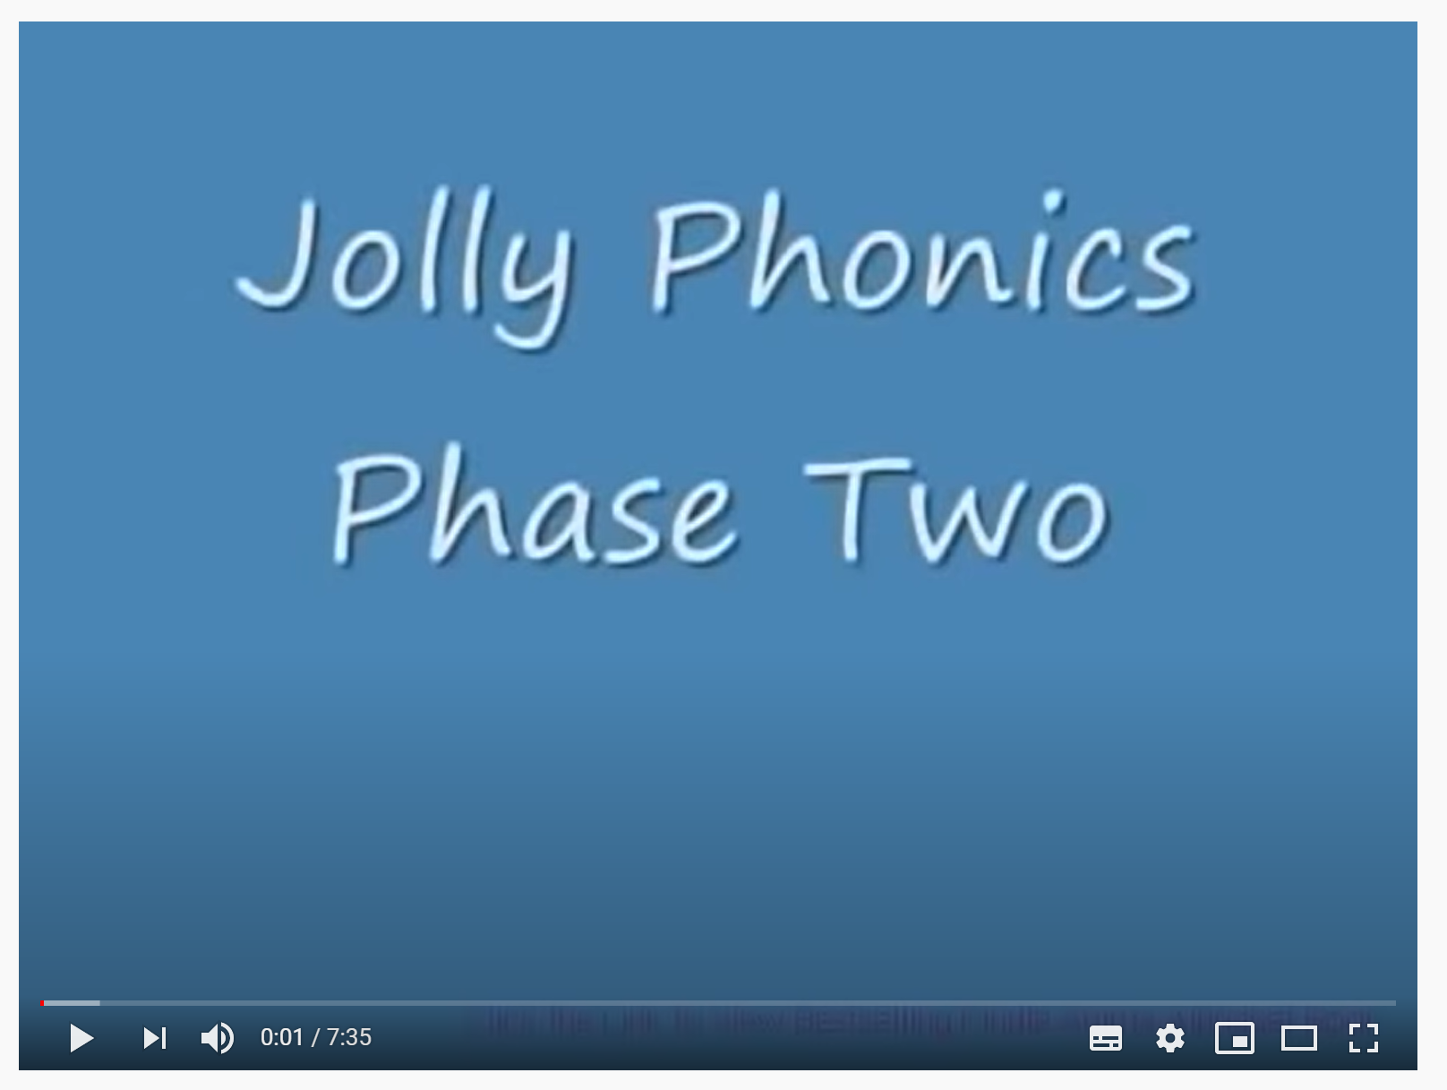  Today’s activity is –  Play blending jump. Write giant letters on separate pieces of paper. Jump on the sounds to blend them together. Today’s words are – sat, pin, dog, cot, gap, pig, dig. | The Number of the week is 4.  Today’s activity is – can you draw the numberblocks 1 – 5.  Help your child work out what numberblocks go together to make new number.  E.g. Numberblock 2 and 1 make 3.  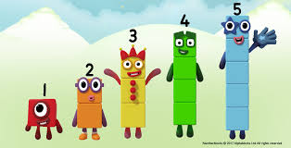 | What is this shape?  Can you find this shape around your house?  How many sides does this shape have?  Practise drawing this shape.

