Morning Year 6,
I have done you a timetable for the week. The resources that you need are below the timetable. These can either be written on paper or typed on a computer. Have a good week, we miss you. Miss Coar.
Tuesday | English  LO: To be able to use the chunk-the plot provided to plan ideas for my story.  Read the chunked plot and then start to create your own ideas for your story.  Think about the skills we have looked at so far this half term and think where they would fit best (expanded noun phrases, fronted adverbials, ing opening clauses, speech, relative clauses)  If you are unsure about relative clauses, search on Google/BBC bitesize. | Maths  LO: To multiply a 4 digit number by a 1 digit number  Start with your timestable sheet (attached on the website) and time yourself to see how long it takes you. Try to beat your time each day.  Main lesson:  Use the formal method (column multiplication) to work out the calculations. | Science:  LO: To research the main characteristics of some invertebrate groups  Using the internet, they researched the characteristics of a number of invertebrates.  Make notes.  .
Wednesday | LO: To gather content for my own shop description.  Use the video links below to start to gather ideas for how you want your magical shop to look.  Think about the vocabulary that you can use.  Use the table to make notes of the things you like from each video clip to create your own magical shop.  Clip from the film Harry Potter and the Philosopher’s Stone (2001 Rating PG): YouTube: Diagon Alley – Harry Potter  and the Philosopher’s Stone: https://www.youtube.com/watch?v=z-WEzhyc3DY  - Clip from the film Mr. Magorium’s Wonder Emporium (Rating U): YouTube: ‘Mr. Magorium’s Wonder Emporium –  Trailer’: https://www.youtube.com/watch?v=m4jAPm__YYI  - Mr Benn: YouTube: Mr Benn – (Full Episodes): https://www.youtube.com/watch?v=0GYJ7H-oqnY&list=PLLhOnau-tupRahc55SIt7g6huhuJSQeDJ&safe=active - Mystery Shop Jewellery Box: YouTube: Teachers TV – Writing a Mystery Story – Jewellery Box:  https://www.youtube.com/watch?v=aJ8onkCF_lI | Maths  LO: To multiply a 3 digit number by a 2 digit number  Start with your timestable sheet (attached on the website) and time yourself to see how long it takes you. Try to beat your time each day.  Main lesson:  Use the formal method (column multiplication) to work out the calculations.  https://www.youtube.com/watch?v=M9_goDnS8Wg&safe=active | Science:  LO: To research the main characteristics of some invertebrate groups  Create a fact file.  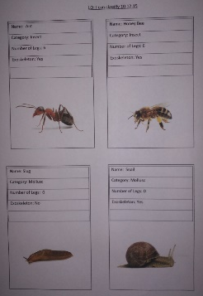  Below is an example.

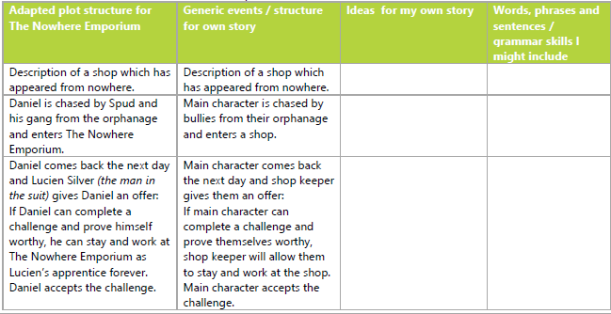
Tuesday:

Multiply 4 digit by 1 digit

1271 x 7 =
2317 x 3 =
6243 x 6 =
4784 x 8 =
9624 x 6 =
3286 x 9 =

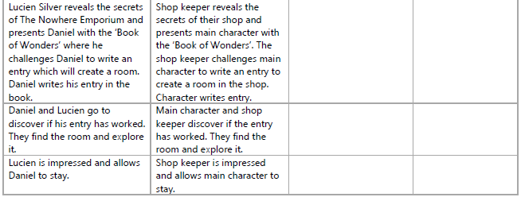

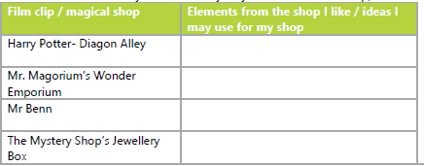
Wednesday:

Multiply 3 digit by 2 digit
286 x 42 =
397 x 65 =
984 x 78 =
Multiply 4 digit by 2 digit
4186 x 34 =
9826 x 76 =
3284 x 53 =
7315 x 98 =
5196 x 42 =

