Maths | 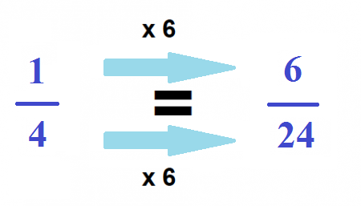  Equivalent fractions  Try to find equivalent fractions by multiplying.  You can find an equivalent fraction by multiplying the numerator and the denominator by the same number.  Complete the fluency section followed by the probing questions on the next page.
English | Letter to Grandma and Grandad  You have survived the terrible Tsunami…  You are still on holiday in Indonesia.  Think about the events so far – you have been on the beach, mum let you have an elephant ride while she went swimming and then the elephant you were on has run off into the depths of the jungle. You have no idea where mum is or if she is even alive.  You will need to write a letter to Grandma and Grandad in role as Will telling them about the events that have happened since you have arrived. Think about the layout of a letter when writing.
 | French  Learn some names of food in French.  See the French words attached on the website.  Have a go at speaking, saying what you would like to eat. | Geography  Read through the powerpoint on the next lesson of trade.  This will teach you about the global supply chain; the journey that things make from source (where they came from) to sale (where they are sold).  Task: Use the sorting cards (see website) and read each one carefully. Order with numbers first and then try to stick or place them in the correct space, primary, secondary or tertiary.

