Tuesday 13th October
Maths – Recap repeated patterns
Please complete the following activities. You can visit the website – https://whiterosemaths.com/homelearning/early-years/week-3/to watch videos to support your child’s understanding.
Watch Numberblocks – Pattern Palace – available on bbc iplayer. This will help support your child’s understanding of repeated patterns.

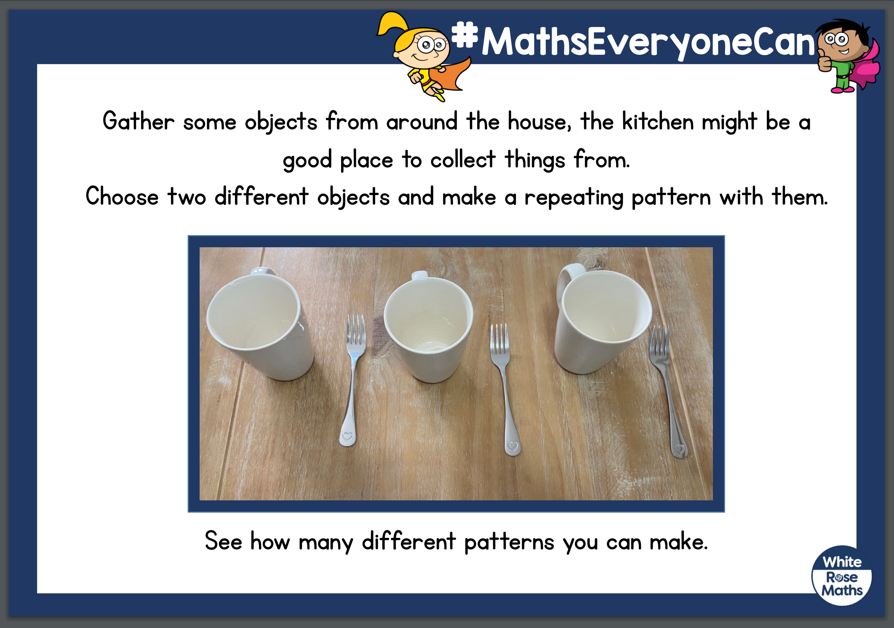

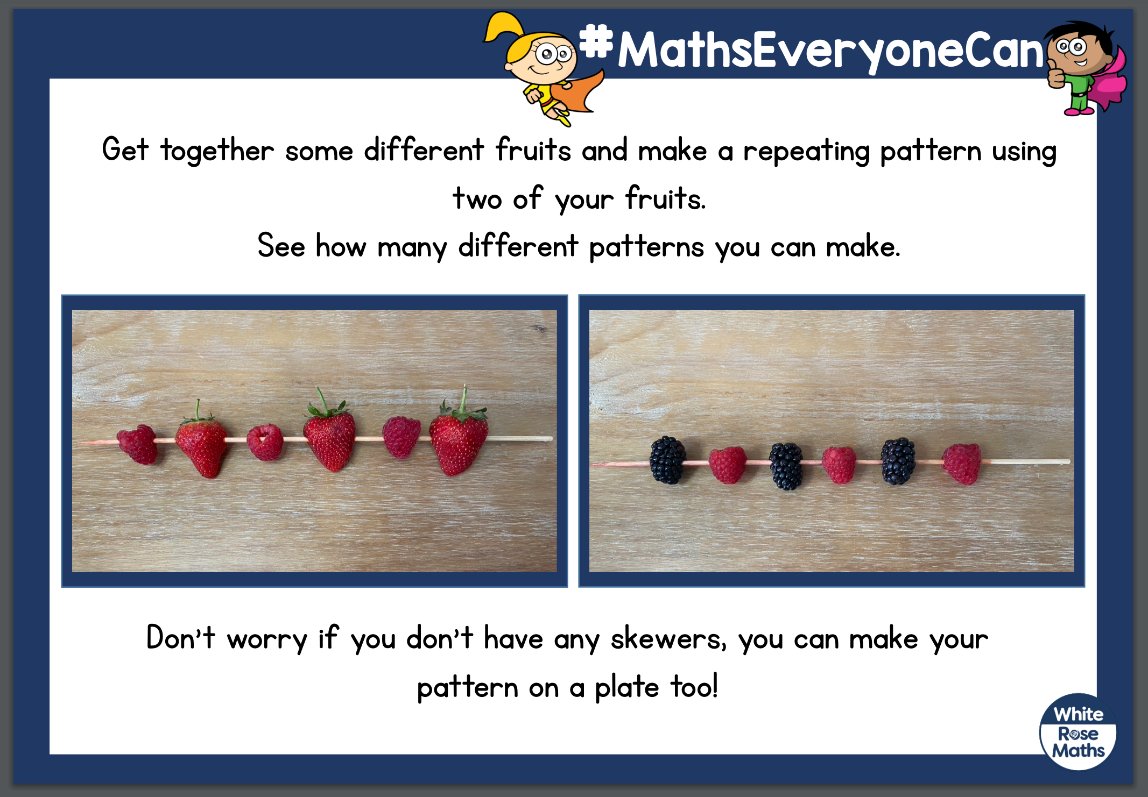

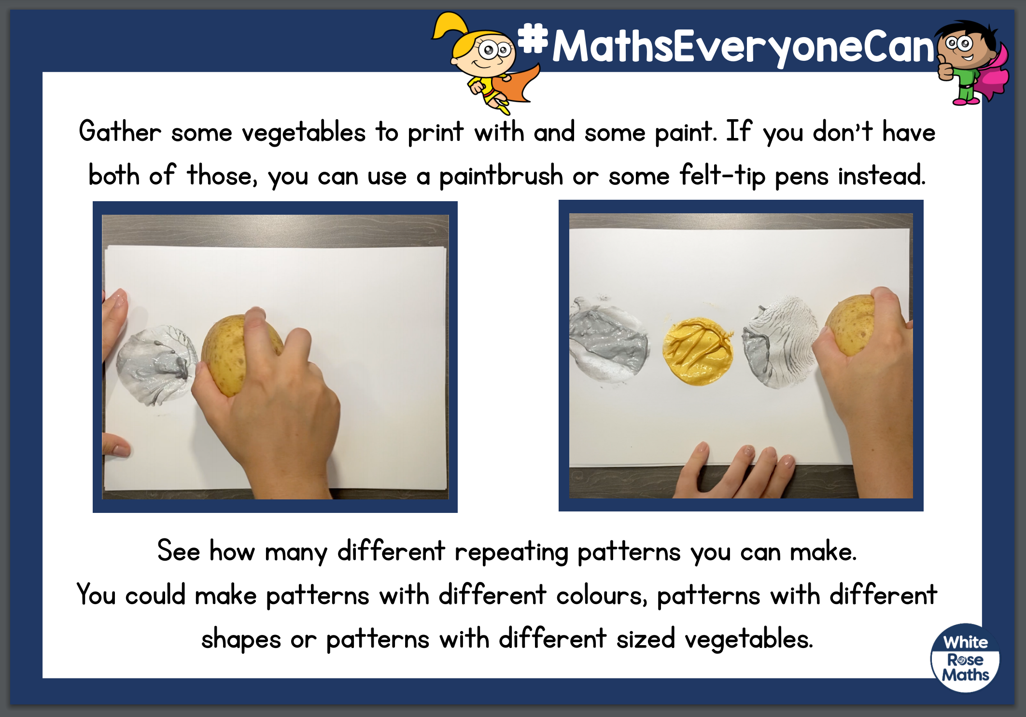

Don’t forget to practise writing your name every day! This week’s spellings are on the website.

Phonics activity | Number activity | Shape activity
Letter of the day – g  The action to this sound can be found on youtube – if you search jolly phonics phase 2 song.  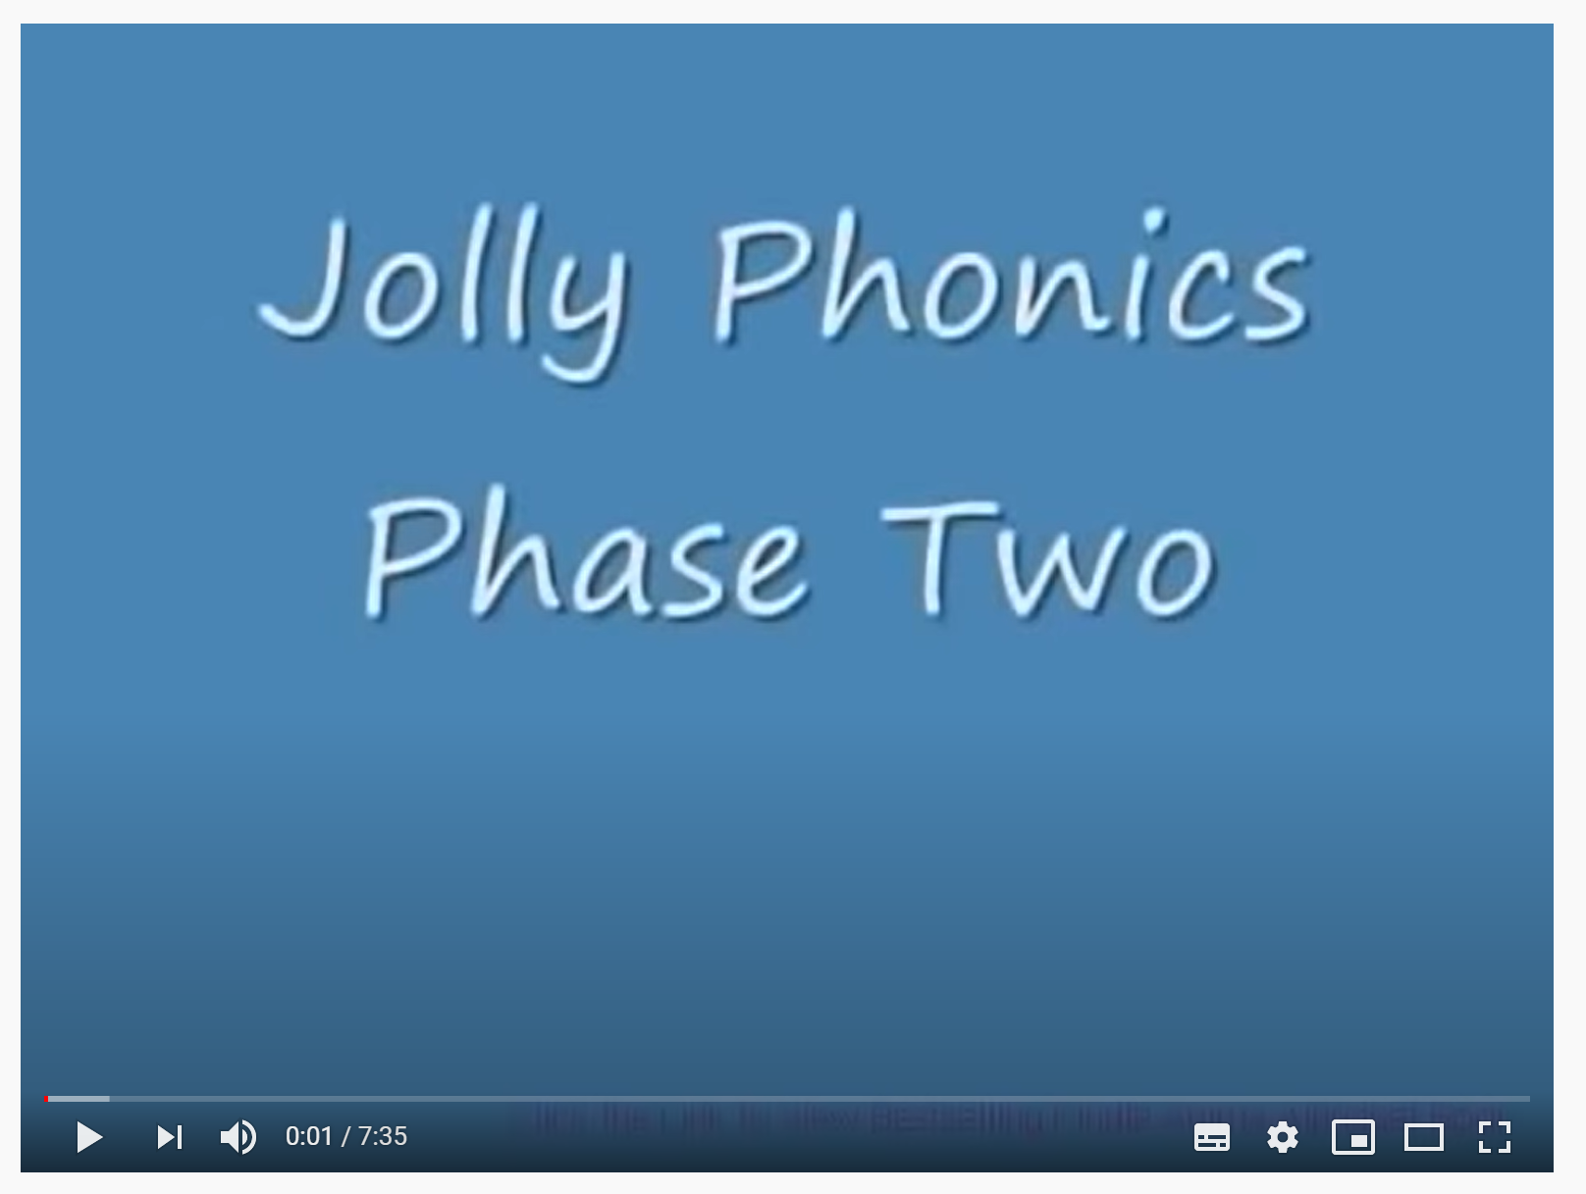  Today’s activity is – play buried treasure – phase 2 – letter g. This is available on www.phonicsplay.co.uk.  Can you blend to read the words dog and dig? | The Number of the week is 4.  Today’s activity is -ordering –  Can you write the numbers 1 – 5 on separate pieces of paper (like number cards.) Now mix them up and put them in the correct order. Can you find the correct amount of objects for each number? | What is this shape?  Can you find this shape around your house?  How many sides does this shape have?  Practise drawing this shape.

