Tuesday 13th October
Maths – Recap on learning so far.
The games are available on the following website:
https://home.oxfordowl.co.uk/kids-activities/fun-maths-games-and-activities/
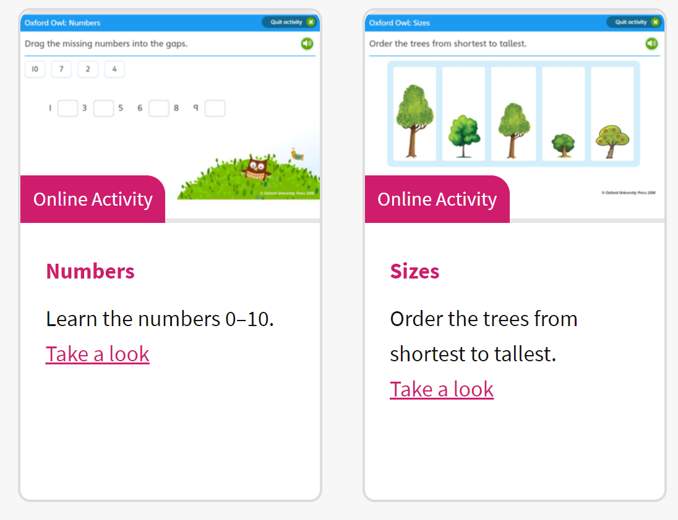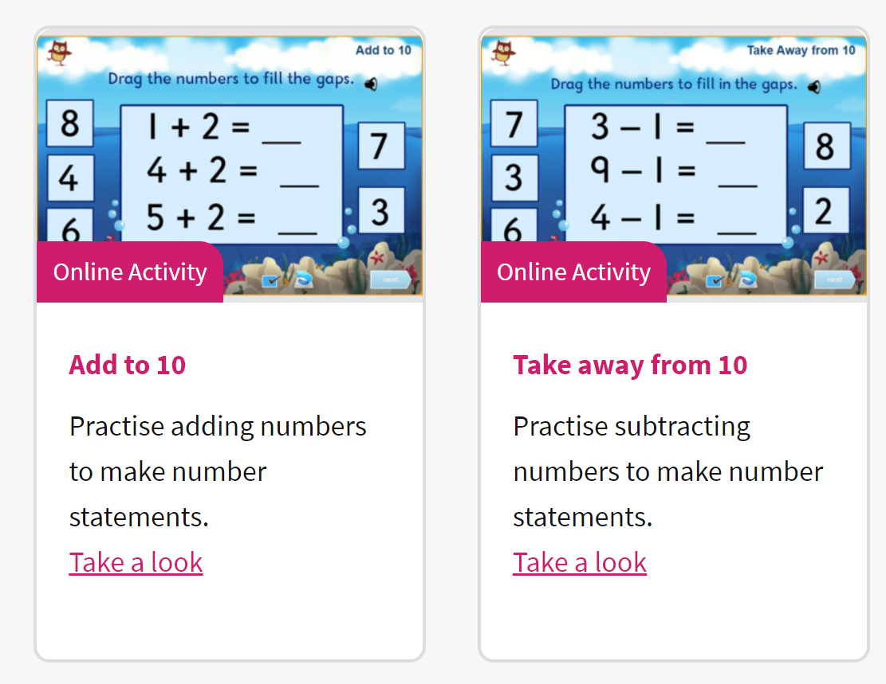

Please complete the following activities. These will help your child recap all their learning in Maths so far.

Don’t forget to practise writing your name every day! This week’s spellings are on the website.

Phonics activity | Number activity | Shape activity
Please practise writing the spellings for this week. | The Number of the week is 5.  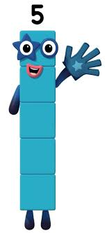  Can you sing 5 little ducks …. Do you notice what happens each time they come back? The amounts gets one less. You could draw the ducks and cross them out each time it gets one less.  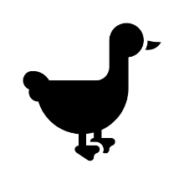 | What is this shape?  Can you find this shape around your house?  How many sides does this shape have?  Practise drawing this shape.

