Moor Nook Community Primary School

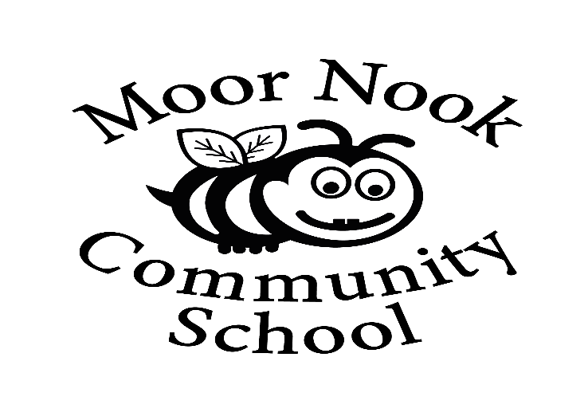

Health, Relationships and Sex Education Policy

April 2020

Health and Relationships and Sex Education Policy 2020

Introduction

- This policy covers our school’s approach to Health and Relationships and Sex Education.
- It was produced with guidance from the PSHE Association and through consultation with our staff, board of governors, and parents.
- It will be reviewed on a regular basis (every 2 years) to ensure that it reflects the attitudes and belief of the school population and remains up to date with both current guidance from Government and the DfES but also remains relevant to the experiences of our pupils.
- We recognise that as a school we have a legal responsibility under The Relationships Education, Relationship & Sex Education and Health Education (England) Regulations 2019, made under sections 34 & 35 of the Children & Social Work Act 2017, to provide comprehensive Relationship Education and Health Education for all pupils receiving primary education.
- We acknowledge that in order for children to embrace the challenges of creating a happy and successful adult life, pupils need knowledge that will enable them to make informed decisions about their wellbeing, health and relationships and to build their self-efficacy. We understand that high quality, evidence-based and age-appropriate teaching of these subjects can help prepare pupils to develop resilience, to know how and when to ask for help.
- As part of the Education Act 2002, all schools must provide a balanced and broad-based curriculum which promotes the spiritual, moral, cultural, mental and physical development of pupils at the school and of society, whilst also preparing pupils for the opportunities, responsibilities and experiences of later life.
- We recognise that we have a responsibility under the Equality Act 2010 to ensure the best for all pupils irrespective of disability, educational needs, race, nationality, ethnic or national origin, sex, gender identity, pregnancy, maternity, religion, sexual orientation or whether they are looked after children. As a result, RSE needs to be sensitive to the different needs of individual pupils and may need to adapt and change as the pupils of the school change. Not only does the teaching need to be sensitive of these needs, but also to help the pupils realise the nature and consequences of discrimination, teasing, bullying and aggressive behaviours or prejudice-based language.
- Whilst as a school we are aware we need to be mindful of and respectful to a wide variety of faith and cultural beliefs, and we will make every attempt to be appropriately sensitive; equally it is essential that young people still have access to the learning they need to stay safe, healthy and understand their rights as individuals. This must include clear, impartial scientific and factual information on matters such as; naming their body parts, puberty, menstruation, masturbation, the variety of family structures, same-sex marriage, marriage and civil partnerships, gender identity, gender equality, sexuality, contraception. Furthermore, all teaching should reflect the law as it applies to relationships, marriage, adoption and care.
- We acknowledge that all young people deserve the right to honest, open and factual information to help better form their own beliefs and values, free from bias, judgement or subjective personal beliefs of those who teach them.

Defining Relationship Education:

- The Department for Education defines relationships education as, teaching the fundamental building blocks and characteristics of positive relationships, with particular reference to friendships, family relationships and relationships with other peers and adults.
- However, we believe comprehensive relationship education is designed to help children to develop the skills to recognise and manage healthy relationships both online and in the real world. It is designed to build self-esteem and to explore personal identity.
- It is about helping children understand and make sense of the world they are growing up in; to recognise the differences and similarities between their peers and their families; to understand the fact every human being is unique and has the right to be respected. There are many different family structures and all children have the right to feel safe.
- Comprehensive relationship education has been shown to help keep children safe by allowing them to understand appropriate and inappropriate touching, to realise that their body belongs to them. It is about building the foundations of an understanding of consent and personal boundaries; in that no one has the right to touch you in a way you don’t like but also the difference between public and private behaviours.
- It is important for children to know the names and functions of their body and to be reassured it is natural to be curious about them. Indeed, by teaching children the correct terms for their private parts, children are proven to be safer from abuse.
- In addition, we believe comprehensive relationship education helps children to develop their vocabulary and emotional literacy to enable them to talk about and manage their feelings. It helps children build their own support networks and the confidence to ask for help when they feel unsafe. This is a required element of the Health Education Guidance.

Defining Sex Education at Primary School:
- Although The Relationships Education, Relationship & Sex Education and Health Education (England) Regulations 2019, made Relationship Education compulsory in all primary schools, Sex education is currently not compulsory. However, the Department for Education continues to recommend that all primary schools should have a sex education programme tailored to the age and maturity of the pupils.
- As set out in the guidance it is up to individual schools to determine whether they need to cover any additional content on sex education to meet the needs of their pupils. We, like many other schools already choose to teach some aspects of sex education and will continue to do so.
- We recognise that some parents may be uncomfortable with the thought of their children receiving sex education in primary school. Equally, we recognise it is completely natural for children to have questions about sex, their bodies and to be curious about where they came from. In the age of information where children in primary school have access to the internet through mobile technology, we believe it is better that children receive age appropriate answers from us than it being left to their peers or the internet.
- In our school sex education is an opportunity to answer children’s questions about where they came from, an opportunity to explore their own stories and to be clear about how a baby is conceived and formed as set out in human life cycle set out in the national curriculum for science.
- Furthermore, our curriculum ensures that all children are prepared for both the physical and emotional changes of puberty including menstruation. Children need to understand how both girls’ and boys’ bodies function and change as they grow into adults. This is included in the statutory health education requirements.
- We believe that sex education should allow children a safe space to ask the questions they may have without shame or judgement. Evidence states that a graduated age-appropriate spiral curriculum is the best way of preventing the topic of sex, reproduction and private body parts of becoming taboo and children from becoming embarrassed by the topic.
- We believe it is the duty of our school to give our young people the learning that will enable them to live safe, fulfilled and healthy lives. This includes ensuring that they have the skills to keep themselves safe from harm and develop positive and healthy relationships, free from exploitation pressure or abuse.
Implementation

- In school we meet the learning objectives as set out in the Relationships Education, Relationship & Sex Education and Health Education (England) Regulations 2019 for primary schools with a whole school approach.
- 1 decision along with other quality assured resources are implemented in every class is delivered by the classroom teacher or a supporting member of staff in that class, importantly someone who knows the children. The local authority delivers ongoing support and training to all staff to ensure they are confident and competent to deliver the materials appropriately and safely. This includes training around safeguarding and answering children’s questions age appropriately.

Curriculum design

Our RSE programme is an integral part of our whole school PSHE education provision and will cover all relevant objectives highlighted below. We will ensure RSE is matched to the needs of our pupils by regularly reviewing the objectives and activities set, highlighting needs and assessing each child individually Our RSE programme will be taught through a range of teaching methods and interactive activities.

The programme covers all necessary approaches to relationship education, using online plans, videos and work to fit the needs of all pupils.

All objectives and lessons are planned around the DFE guidance and statutory requirements and have been checked and PSHE Association Quality Assured.

Across Key Stages One and Two, these topics are covered-

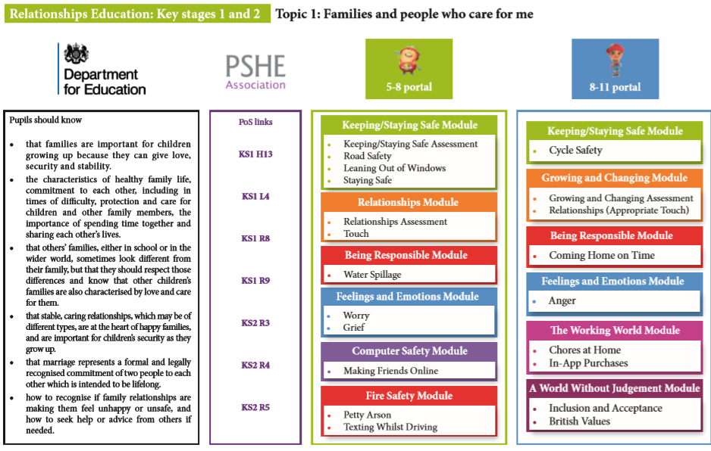

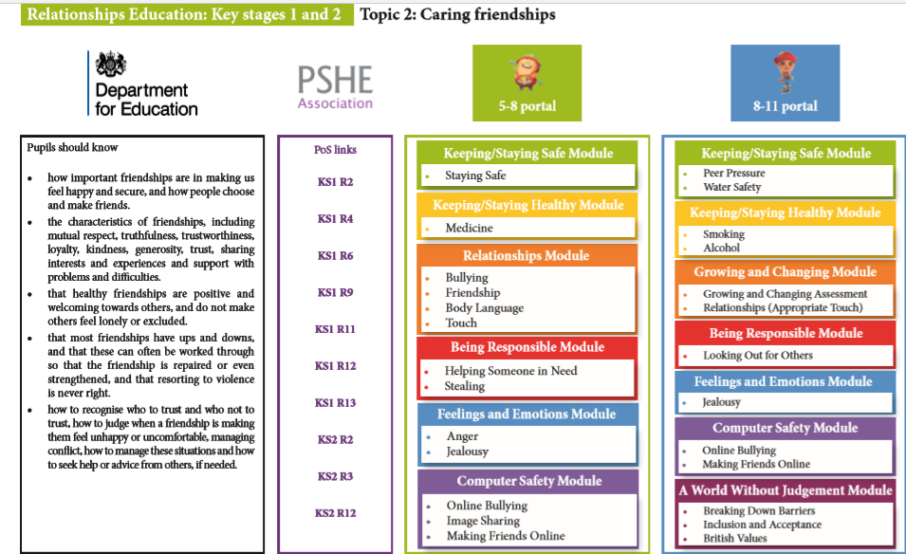
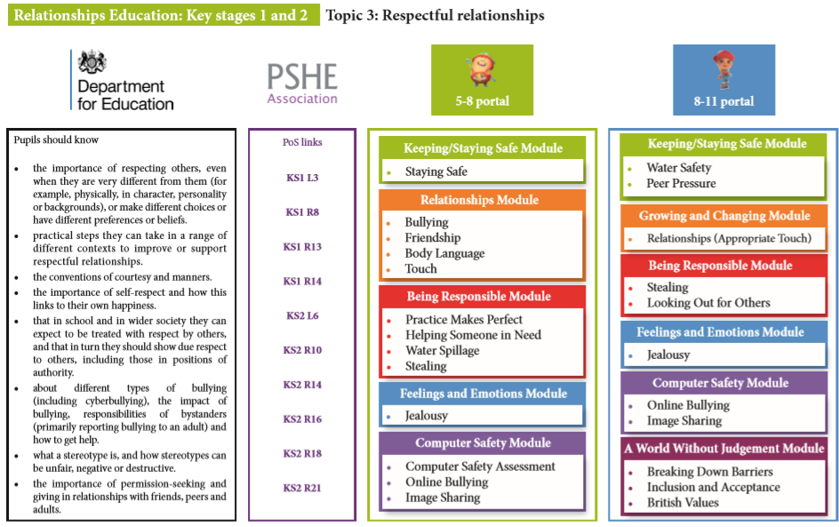

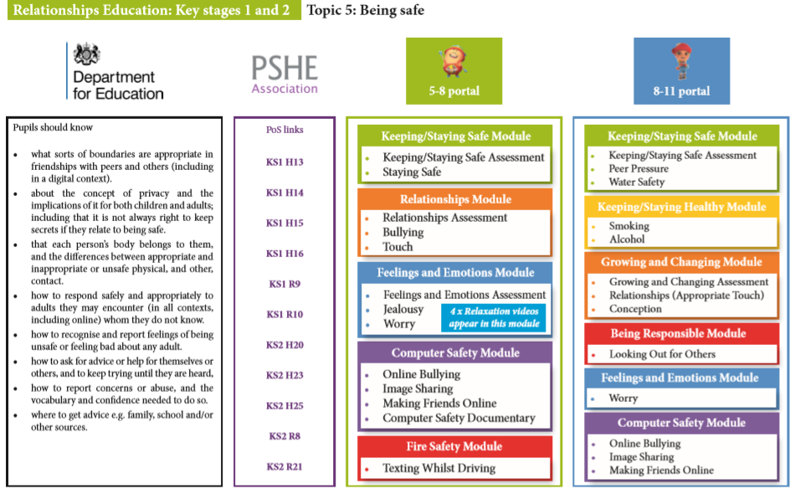

Answering Children’s Questions:

Please refer to PSHCE policy on how as a school we respond to children’s questions.

Parents and parental rights to withdraw:
We believe that successful teaching around RSE can only take place when parents and school, work together. Especially, considering we both want children to grow up safe and happy in healthy relationships, with the ability to manage their emotions and speak up when they feel unsafe. Therefore, we are committed to working together with parents.
- We endeavour to be transparent and give parents information about all the programmes and lessons we deliver around RSHE as we recognise it can be a sensitive subject for some families for a number of reasons.

- We recognise the importance of parents knowing about the content of the lessons so they can carry on the conversations at home and have an opportunity to talk to their children about their own families, beliefs and values.

- We recognise under the new draft guidance for Relationship Education, Relationship & Sex education and Health Education (DfE 2018), parents retain the right to request their child is removed from some or all of the elements of sex education which go beyond the national curriculum for science. Maintained schools are required to teach about the main external body parts and changes to the human body as it grows from birth to old age, including puberty. There is no right to withdraw from the national curriculum.

- Should a parent decide that they do not wish their child to take part in any of the non-statutory lessons, we would ask parents to contact the school office to arrange a meeting to discuss this with the head teacher to discuss their concerns. We will happily show parents all the teaching material and context of any of our lessons and explain the reasons why any material is included in the programme. We will also highlight that whilst parents have the right to withdraw their child from these lessons, they do not have the right to withdraw other children from receiving these lessons. We believe it is better for children to hear from safe adults than to hear second hand from their classmates at break-time.

Policy on Menstruation:

- We recognise that the onset of menstruation can be a confusing or distressing time for children if they are not prepared. As a school we acknowledge we have a responsibility to prepare children for menstruation and make adequate and sensitive arrangements to help children manage their period. Especially children whose family may not be able to afford or will not provide sanitary products.

- We recognise that period poverty exists in the UK and that some children are forced to avoid attending school if they are on their period, when they are unable to manage it sensitively. We do not want that to be the case in our school and will make every reasonable effort to support children to access their education and enjoy school.

- Puberty is occurring earlier than ever before, and it is now not uncommon for children to start their periods whilst in primary school even in year 4. For this reason, we may puberty lessons to all children starting from year 4, 5 & 6.

- As part of these lessons all children will be told about menstruation and there will be discussion of what periods are, explanation of other symptoms associated with periods, how they can be managed hygienically, and sensitively.

- During lessons where puberty and menstruation are discussed, we will take the opportunity to highlight the location of sanitary bins available in school, and how these are to be used.

- In school we have a menstruation kit available which contains sanitary products. Children will be made aware of where these are kept and how they can be accessed through designated members of staff, including lunchtime supervisors.

Safeguarding Children:
- When teaching any sensitive topic, such as RSE which deals with family life, safe and appropriate touching, personal body parts and healthy relationships, we recognise the potential to uncover incidents of abuse through children’s disclosures.
- All members of staff who deliver any of our Relationship or Sex Education Programme, have statutory training around safeguarding children and are all aware of our school’s safeguarding policy and procedures in the case of a disclosure or suspicion of a safeguarding concern.
- It is our practice to review safeguarding procedures in team meetings before the programme is delivered. Furthermore, if relevant, there may be conversations around protecting and supporting children for whom some of this work may make them vulnerable due to previous safeguarding concerns, past child protection investigations, ongoing concerns or changes in family or living situations if these may be triggered by scenarios or topics in their planned lessons.
- We recognise that for children who may be vulnerable due to past or present abuse or changes in family situations, this type of work, whilst it may be sensitive, there may be needs to adapt the programme or offer additional support. It is also a protective factor in preventing further abuse, to help them make sense of their experiences and essential to help them develop skills and resilience to keep them safe in future.

Monitoring & Evaluation:
The person responsible for RSE in schools will monitor progress and evaluate on the effectiveness of lessons and programmes of study regularly, using evidence from workbooks, discussions with staff and pupils as a basis for teaching guidelines in accordance with DFE guidelines.

Review date: April 2022

