Morning Year 6,
I have done you a timetable for the week. The resources that you need are below the timetable. These can either be written on paper or typed on a computer.
I would like to see the work you have produced when you return. Have a good week, we miss you. Miss Coar.
The work for maths is after the timetable.
Monday | English  LO: To use expanded noun phrases and relative clauses.  Relative clauses begin with a relative pronoun, who, whose, which, that, where.  Example:  - The boy, who was standing at the bus stop with his mum, was excited to go and see his grandparents.  - The glass jar, which was sat on the top of a wooden desk, was bubbling.  Task:  Today you will write the next part of your story.  So far, your main character has run away from the bullies and entered a shop. Today you will describe the inside of the shop and then the main character leaves and comes back the next day and shop keeper gives them an offer:  If main character can complete a challenge and prove themselves worthy, shop keeper will allow them to stay and work at the shop. Main character accepts the challenge.  You need to use all your ideas from your planning last week, the ideas you took from the film clips etc and you may take ideas from the images we looked at in the very first week of Year 6 of the magical shops to describe the inside of the shop. | Maths  LO: To multiply a one-digit number with up to 1 decimal places by a two-digit number using a columnar method  Start with your times table sheet (attached on the website) and time yourself to see how long it takes you. Try to beat your time each day.  Main lesson:  Use the formal method (column multiplication) to work out the calculations. Today you will be looking at multiplying decimals by two-digit numbers. The decimals are to one decimal place.  I have tried my best to show you the lay out for this below.  7. 6 Note: We do not put a decimal in between the 2  x 2 3 and the 3 because it is 23 not 2.3.  . However, we do have to put decimal points  . in each of our rows for our answers.  . | Science:  LO: To describe how living things are classified into broad groups according to common observable characteristics and based on similarities and differences  By now you will have researched and expanded your knowledge classifying some living things such as plants (flowering plants and non-flowering plants), vertebrates (mammals, birds, fish, amphibians and reptiles) and invertebrates.  Task:  Today, your task is to research viruses, fungi and bacteria. These are too living and are in a group called microorganisms.
Tuesday | LO: To create complex sentences by using relative clauses with relative pronouns who, which and that  Today you will continue with the story.  The next section is…  The shop keeper reveals the secrets of their shop and presents main character with the ‘Book of Wonders’. The shop keeper challenges main character to write an entry to create a room in the shop. Character writes entry.  Task:  When you get to the section where you write your entry in the Book of Wonders, you can choose from the following to appear:  - An island  - A desert  - A rainforest/jungle  - Antarctica  Use word hippo and images on Google to help support you with description. Think about the things you would see, hear and smell. Take the reader on a descriptive journey. Use fronted adverbials to help locate where things are. | Maths  LO: To multiply a one-digit number with up to 2 decimal places by a two-digit number using a columnar method  Start with your times table sheet (attached on the website) and time yourself to see how long it takes you. Try to beat your time each day.  Main lesson:  Use the formal method (column multiplication) to work out the calculations. Today you will be looking at multiplying decimals by two-digit numbers. The decimals are to 2 decimal places.  I have tried my best to show you the lay out for this below.  Note: This time you will notice because there are two decimal places we just set out the 2 digit number  7. 61  x 23  . we are multiplying by  . underneath.  . | Science:  LO: To describe how living things are classified into broad groups according to common observable characteristics and based on similarities and differences  Using your notes from yesterday, create a non—chronological report.  See an example below.  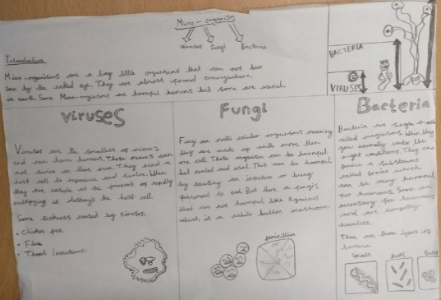
Wednesday | LO: To create sentences for effect  Main character and shop keeper discover if the entry has worked. They find the room and explore it. Shop keeper is impressed and allows main character to stay.  This is the final section of your story.  Today you will try to create sentence for effect using a range of skills we have learnt this half term such as:  - Ing openers  - Fronted adverbials  - Speech  - Relative clauses  - Blending action, dialogue and description | Maths  LO: To divide a 3/4-digit number by a 1-digit number using a written method  Start with your times table sheet (attached on the website) and time yourself to see how long it takes you. Try to beat your time each day.  Main lesson:  Today you will use the bus stop method to divide.  5 4189  Note: Go through this example with me.  How many 5’s in 4? 0 so I carry the 4 across to the 1.  How many 5’s in 41? 8 because 8x5=40. I have 1 left over so I carry that 1 to the 8.  How many 5’s in 18? 3 because 3x5=15. I have 3 left over so I carry that 3 to the 9.  How many 5’s in 39? 7 because 7x5=35. I have 4 left over so I write ‘r4’. This means remainder 4.  Answer: 837 r4 | Science:  End of unit  Think back to when we looked at classification keys. They consist of yes or no questions.  I want you to create a classification key based on animals that are grouped within invertebrates and vertebrates.  You may need to use the internet to support you will question and finding the answers.  Think about:  Does it lay eggs?  Can it fly?  Does it have legs?  Is it cold blooded?  Your first question must be…  ‘Is it a vertebrate?’  Yes or No  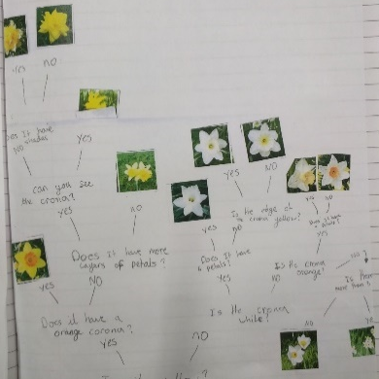  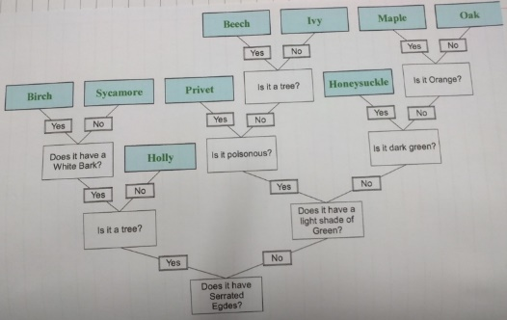
Thursday | Editing and final draft.  Today you will read through your work and write up a final draft. As you do this, you have the opportunity to edit and improve your writing.  You will need to check carefully for spelling, punctuation and grammar errors.  Remember as well as editing your errors, it is also an opportunity for improving.  Note:  You might notice that you have started lots of sentence with ‘he’ and want to improve some of these. It may be that you haven’t used ‘ing’ openers and want to include one. It could be that you found somewhere that you could have added an expanded noun phrase or maybe an adverb to add detail to how an action was completed. | Maths  LO: To divide a 3-digit number by 2-digit number using a formal written method  Start with your times table sheet (attached on the website) and time yourself to see how long it takes you. Try to beat your time each day.  Main lesson:  Today you will use the bus stop method to divide but you will be dividing by a two-digit number so will need to be really careful when counting up for example in 17’s or 21’s.  The process of the bus stop method is the same as yesterday. | LO: I can show I understand my responsibilities for the well-being of others in my online social group  Read the scenarios (on the website) and think about the following;  What has happened? Where would they place the person’s wellbeing on the wellbeing thermometer? How could they tell that their wellbeing might be affected? What they would do to support those affected within the group?  Record the temperature of the people’s feelings.

Maths for Thursday
612 ÷ 12
864 ÷ 24
945 ÷ 21
468 ÷ 36
672 ÷ 42
864 ÷ 15
923 ÷ 23
328 ÷ 32

Maths for Monday
0.3 x 67
0.7 x 34
3.9 x 85
5.4 x 26
8.6 x 94

Maths for Wednesday
8842 ÷ 2
3248 ÷ 4
5766 ÷ 6
2877 ÷ 3
4279 ÷ 5
9759 ÷ 7

Maths for Tuesday
0.38 x 19
0.59 x 74
2.67 x 87
8.34 x 63
5.68 x 54

