Home Learning – Science
This is the gestation period (pregnancy length) for a variety of different animals.
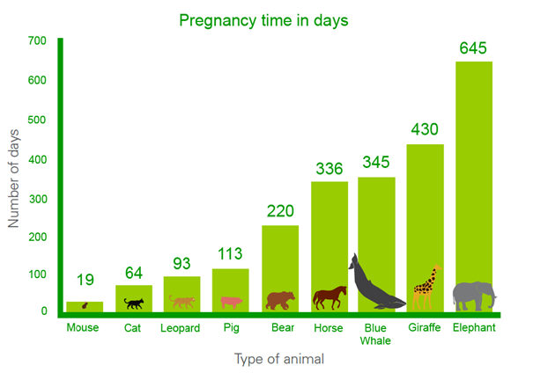
Can you answer these questions about the information (data)?
- Which animal has the shortest gestation period?
- Which animal has the longest pregnancy length?
- Can you spot any patterns about the data?
- Does anything surprise you about the data?
- Can you think of three questions you would like to investigate further?
- Choose one of your questions and find out more.

Home Learning – Art
This week in art, we will continue to create a 3D diorama of a scene from The Lion, The Witch and The Wardrobe.
These photographs might give you some more good ideas and if you have already completed yours, why not try another diorama about a book of your choice?
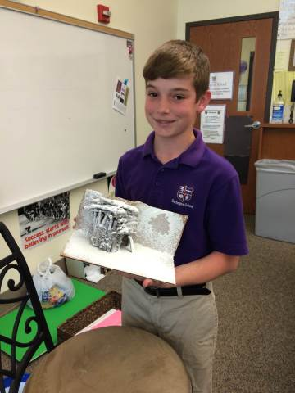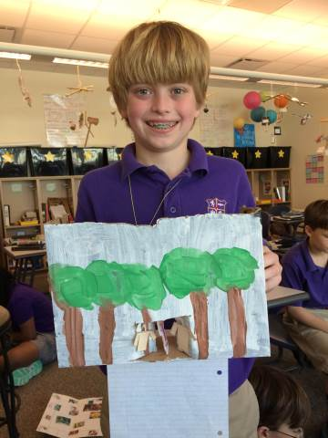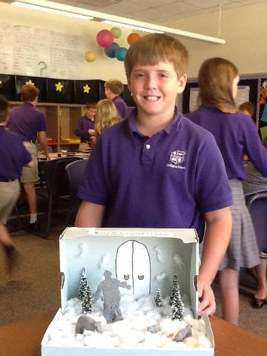

Home Learning – PE
We will continue to be focusing upon Netball and the following skills:
Throwing – Chest pass, Shoulder pass & Bounce pass.
Shooting – Holding the ball at the back and the side, bending knees and shooting in a steady line.
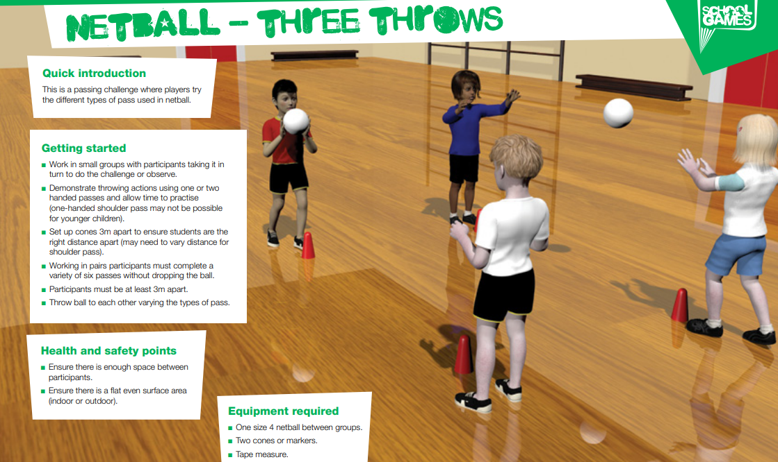
P.S. We are still feeling jealous of your more bouncy balls!
Home Learning – Computing
We are continuing to think about our safety when we are online e.g. tablets, laptops, phones etc.
This week’s focus is making payments online.
Making purchases online can be fun, exciting and give access to new tools, or spaces.
But not all purchases are what you might be expecting.
For example: Giving a gift to a vlogger may give you a phone number, but do you really think a vlogger will give out their real number to anyone who pays for it?
Key Questions to talk about with your parent or carer:
- What is a loot box?
- How do you know if an app is charging you real money?
- Do you have to buy in-app purchases to get further in a game? Why/why not?
- What other types of in-app purchases have you encountered? (e.g. gifting vloggers/popular people on social media).
- What are the benefits/risks of these purchases?
Now play the snakes and ladders type game to think more about this information. See Computing – Snakes and Ladders Game.
