How do Christian’s worship God?
For this lesson you will need to watch this video:
https://www.bbc.co.uk/teach/class-clips-video/religious-studies-ks2-christian-worship/zvjv92p
List the different ways that Christian’s show their love and respect to God.
Task: Can you create this to show your learning?
- Hand out yellow paper.
- Place yellow paper in a diamond shape (with a corner at the top) on the table.
- Fold two corners together.
- Fold other two corners together.
- Keeping paper folded, write 1, 2, 3, and 4 on the corners.
- Open all folds.
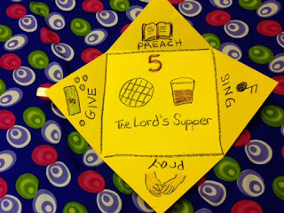
- Turn paper over and write, "HOW DO CHRISTIANS WORSHIP GOD?" in the middle of the square.
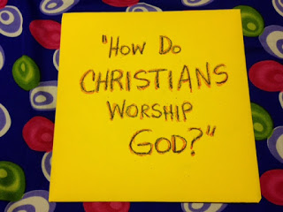
- Turn paper over one more time, fold all corners together.

