LO: To create a map of the school.
Here are the pictures from our school walk last week. You will see: the computer room, library, playground and dinner hall. Your job is to cut out these pictures and create a map of the school. You can add the other rooms and areas to your map such as our Y3 classroom, the school office and other rooms around school.

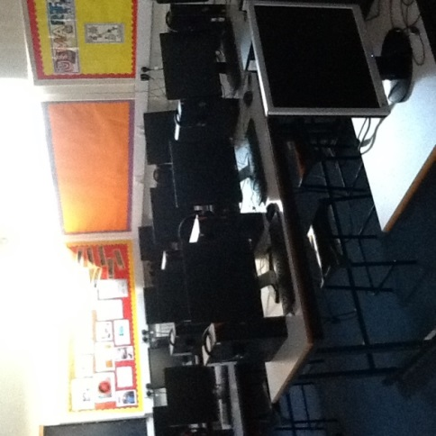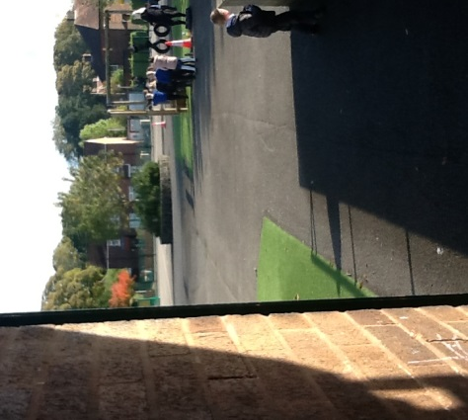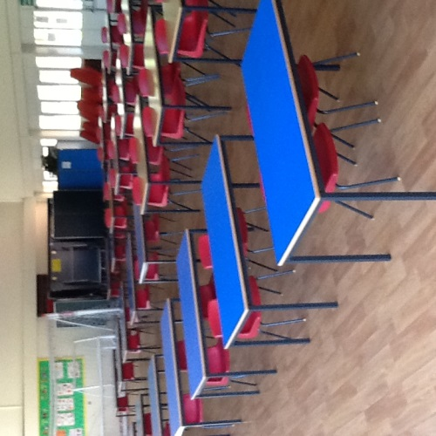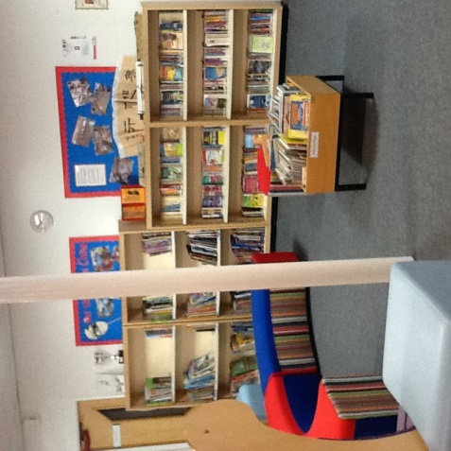
Task 2: Create a map of your local area.
What is around you? Do you have a church? A park? Houses? A school? Shops? Can you draw these on your map? You could use Google Earth / Google Maps to help you. 