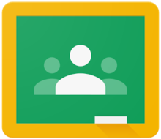
How to login as a child to Google Classroom for the first time – A Guide For Parents and Children

Your child may have had some experience logging in to their account at school. However the aim of this guide is to ensure that they may do this reliably at home.
Your school will provide your child with a secure email login and a password – see below or attached.

Your school may provide a web address to take you directly to their login
or enter classroom.google.com into a search engine such as Google, Safari or Bing.
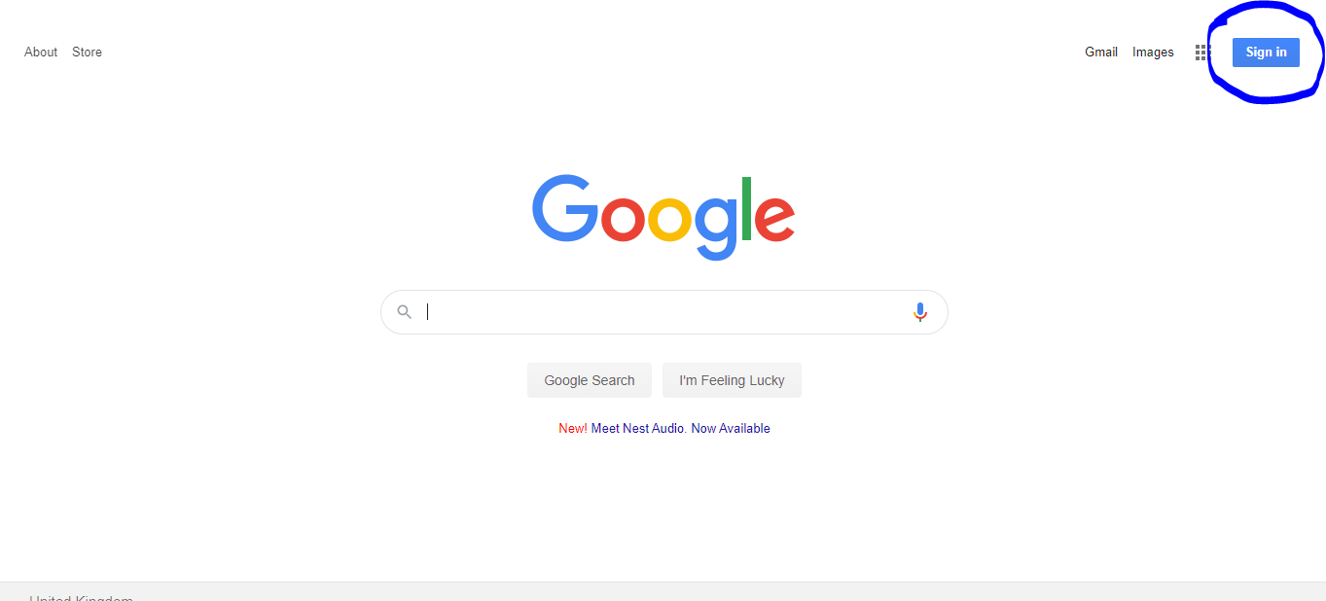

In the top right hand corner, click sign in. Then enter your child’s email address login followed by their password.
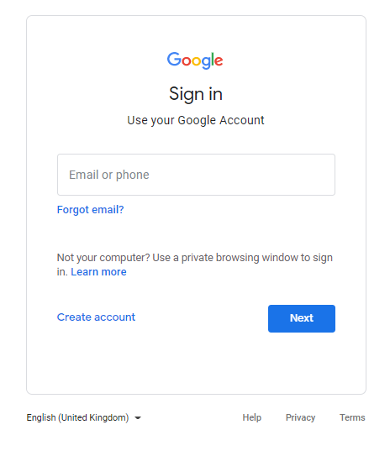
Once you have done this, your child will need to join their class.
The very first time they do this a welcome message may appear and a choice.
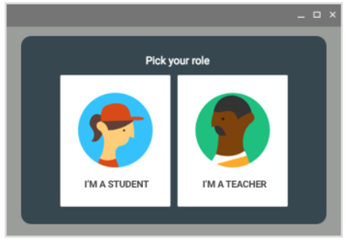
Click I’m a student and Get started.
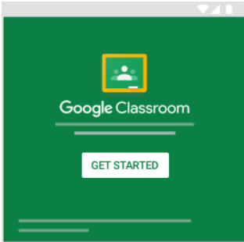

Depending on how their Classroom has been set up – they will need to either just click on their class icon(circled in red) or go to the top right corner and click the + sign (circled in blue)
If you have to go to the + sign you will have been provided with a class code to enter.
Once you have entered your child’s classroom, you will see something similar to the image below.
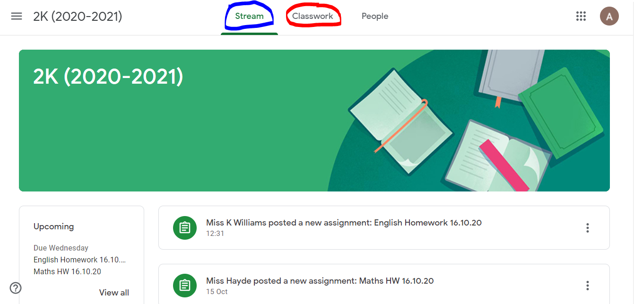
The screen you will see first is the Stream. This page is where you can see updated messages from the teacher and a list of word to do. Some teachers may post important information on this page and it will always be the one parents and children will see first. On the left hand side, a list of upcoming work is provided for information only.
To access your child’s work to do, you either click on the assignment on the Stream or click Classwork at the top of the page in the middle.
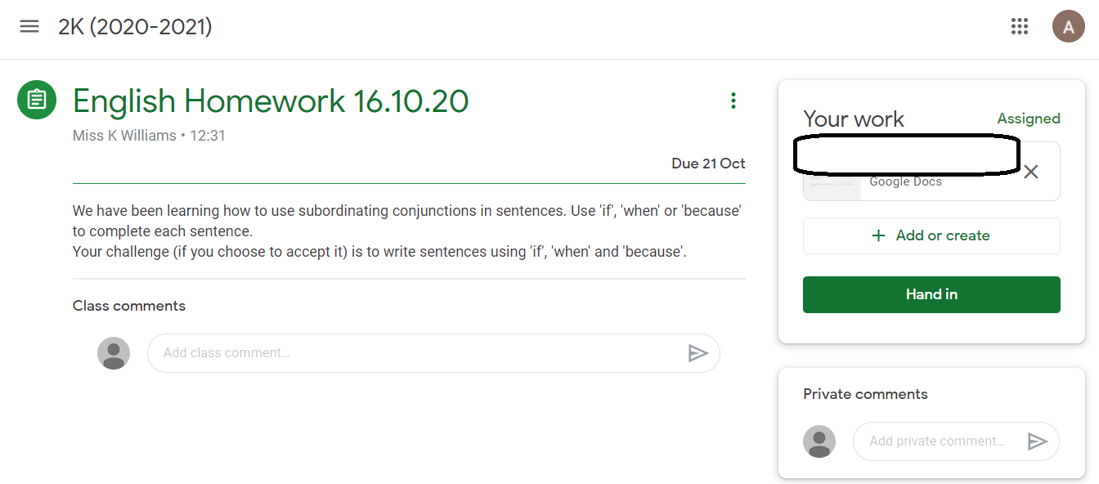
On the left hand side of this screen, you will see the title of your child’s work and the instructions and expectations. On the right you will see your child’s work – indicated by the arrow. Double click to open their work. If the work set is written you may get the option to open with Google docs, this is the easiest way to complete work set in Google Classroom and as your child begins to complete their work a Turn in option will appear. (see below)
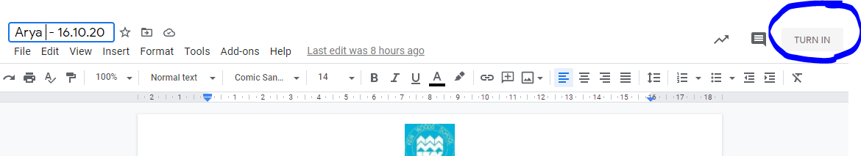
Once you click Turn in, you will see the following message and select Hand in if the work is ready.
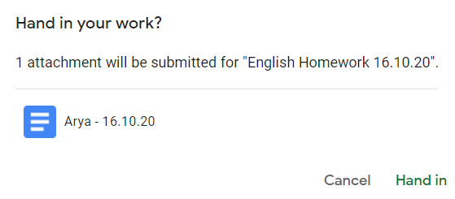

Notes For Using Mobile Devices
Download the Google Classroom app for free.
It should work on Kindles, Android and Apple devices including phones.
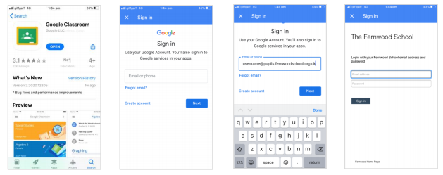
Final Tips
If for some reason your child completes their work but is unable to access the Turn In function, their class teacher should still be able to view their completed work in most circumstances as it is on a shared drive.
Please contact your school if you need further help accessing Classroom, they should be able to help you to overcome any issues.
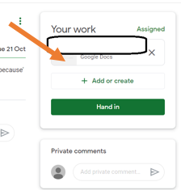
Underneath each piece of work set by their teacher - above the hand in button- there is the option to Add or Create. The Add option allows children to add content such as images or videos whilst the create function gives them access to a range of Google tools. These are useful for the children to learn and provide additional options for completing work if for some reason it is hard to hand in work another way.

