09.10.20
LO: Multiplication arrays
Watch the video: https://www.youtube.com/watch?v=00m3YhLT6fA&safe=active
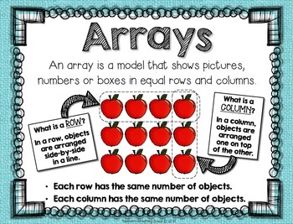
Need more help? Look at the Powerpoint on the school website ’09.10 Amazing Arrays’
