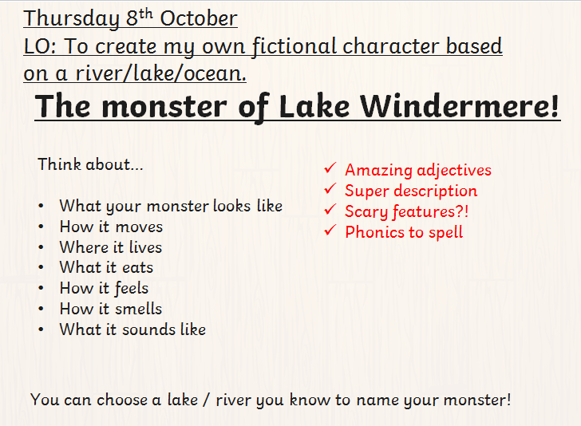

Draw your monster below and write the information around the monster.

