Friday 16th October
Literacy
Now you have read the story ‘The Enormous Turnip’ and made a story map to help you retell the story. Today’s lessons are:
Lesson 3 – to step and speak the story.
Lesson 4 – to dance a story.
Please click this link to access the stories.
https://classroom.thenational.academy/units/the-giant-turnip-79c6
Can you make a picture using all the shapes we have learnt this week?
Look at the example below.
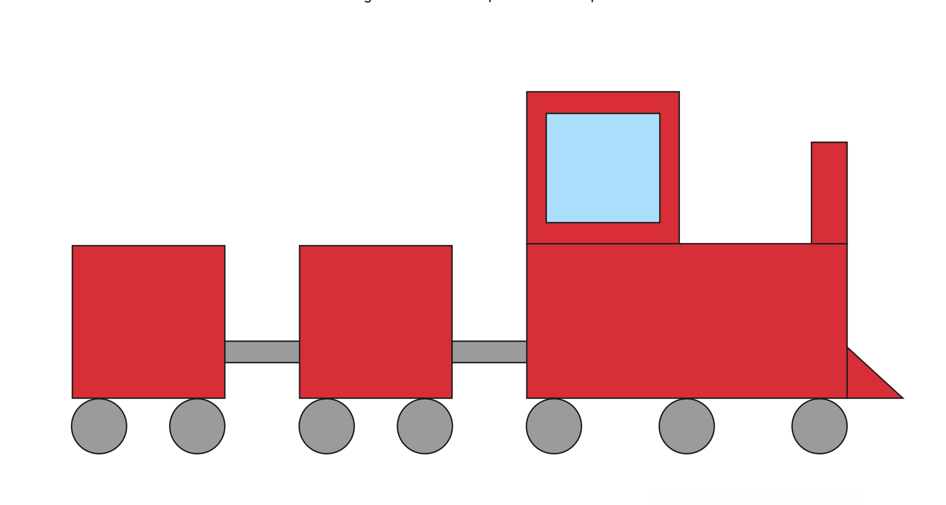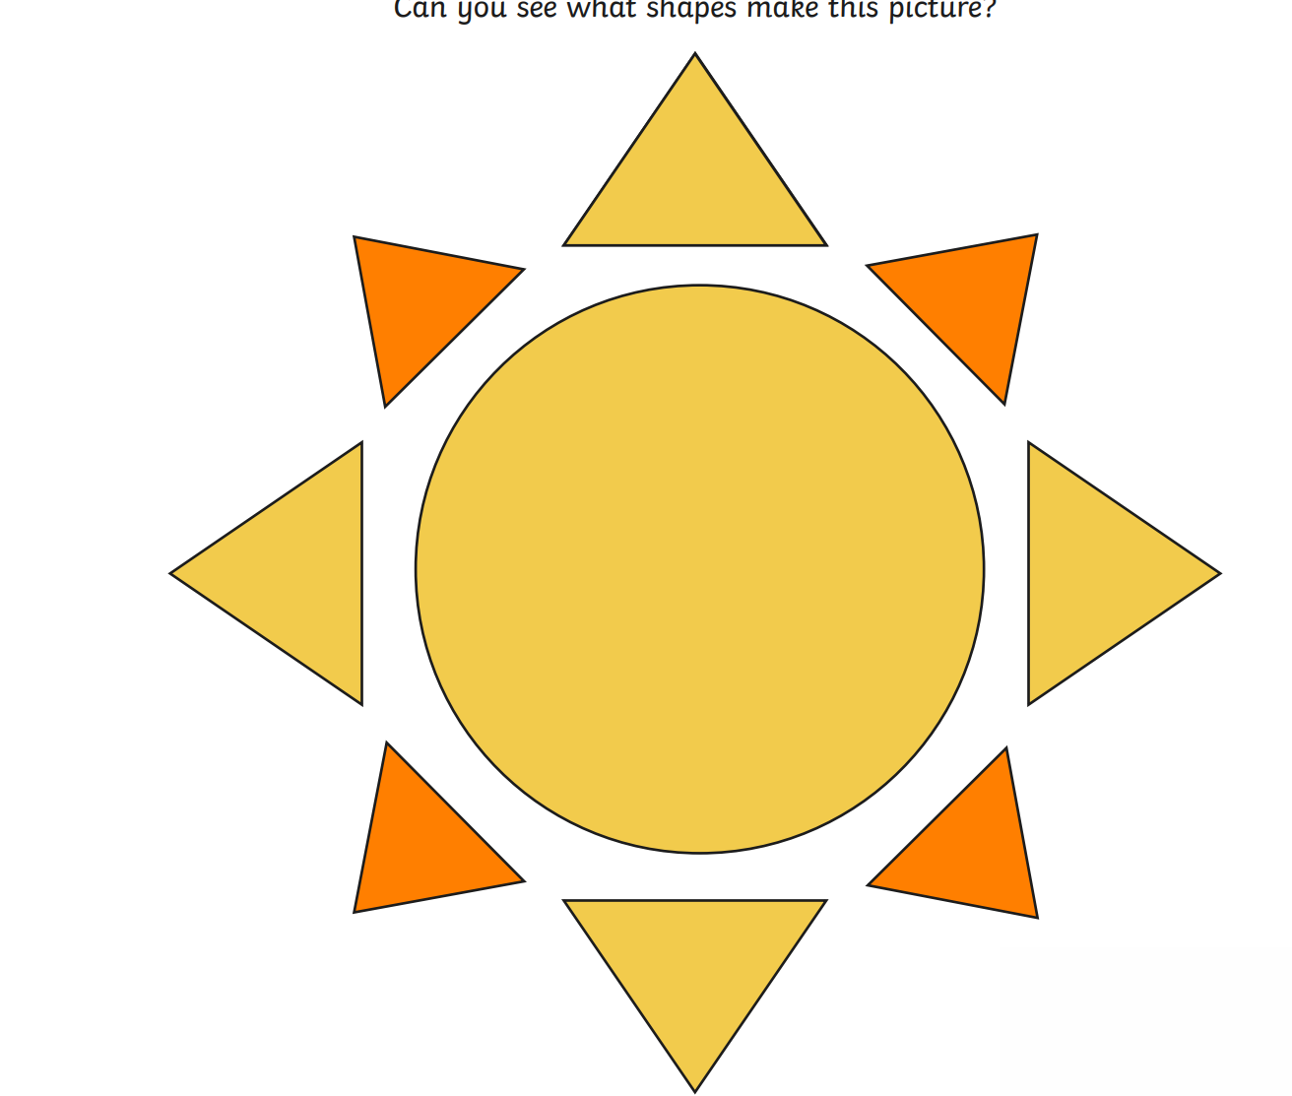

You can email your pictures to reception@moornook.lancs.sch.uk.

Phonics activity
Letter of the day – k
The action to this sound can be found on youtube – if you search jolly phonics phase 2 song.
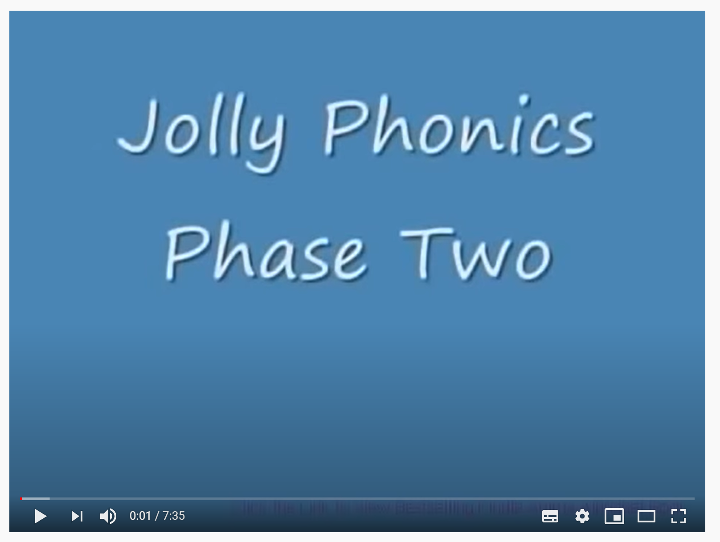

Today’s activity is – Read the sentences and draw the missing items on a piece of paper.
