Phonics
The children have been working extremely hard on their phonics. It would be fantastic if they could watch a daily lesson to practise their phonics. We have been recapping our sounds that we learnt in Reception. Keep it up, Year 1!
ai | https://www.youtube.com/watch?v=siVkXoEQDNc&list=PLuGr6z2H2KNG4XgGr7UylwowIcDLr-T-k&index=94&t=5s
ee | https://www.youtube.com/watch?v=hBFFUCraDt8&list=PLuGr6z2H2KNG4XgGr7UylwowIcDLr-T-k&index=93
oo | https://www.youtube.com/watch?v=7anrdHnwGbs&list=PLuGr6z2H2KNG4XgGr7UylwowIcDLr-T-k&index=92
oa | https://www.youtube.com/watch?v=rrGadCz2A1o&list=PLuGr6z2H2KNG4XgGr7UylwowIcDLr-T-k&index=91&t=338s
Phonics play game to practise your reading
https://www.phonicsplay.co.uk/resources/phase/3

If these links are not working you can google Letters and Sounds at home and school lessons 1,2,3 and 4
If you don’t already have access please sign up to https://home.oxfordowl.co.uk/reading/free-ebooks/
You can than select a book from your child’s book band colour. You can find this colour on the side of the home reading books that they take home in their book bag.

Maths
This week we have been learning about place value and numbers to 20. We will use oak academy videos to help us learn about numbers to 20. I have also provided the worksheets as a back up although these can be done by following the next button on the video.
To count from 1 to 19 and match pictorial and abstract representations of these numbers | https://classroom.thenational.academy/lessons/to-count-from-1-to-19-and-match-pictorial-and-abstract-representations-of-these-numbers-chgkjt
To identify numbers to 20 by counting ten and then counting on | https://classroom.thenational.academy/lessons/to-identify-numbers-to-20-by-counting-ten-and-then-counting-on-6wtkgc
To position numbers to 20 on a number line | https://classroom.thenational.academy/lessons/to-position-numbers-to-20-on-a-number-line-6mw6ac
To identify one more and one less than a number within 20 | https://classroom.thenational.academy/lessons/to-identify-one-more-and-one-less-than-a-number-within-20-ccvkae
To compare numbers to 20 | https://classroom.thenational.academy/lessons/to-compare-numbers-to-20-6mr36c

I am learning to orally retell a story | English  At school we have been reading Harry the Happy Mouse, who helps his friends. You may like to watch/read to the story here:  https://www.youtube.com/watch?v=v7OsfHyqE_M  We drew a story map in class and have been reading each other the story. We have been thinking about how to improve our writing by saying the story/words.  Please use draw your own story map like this one to read the story to the people in your home.  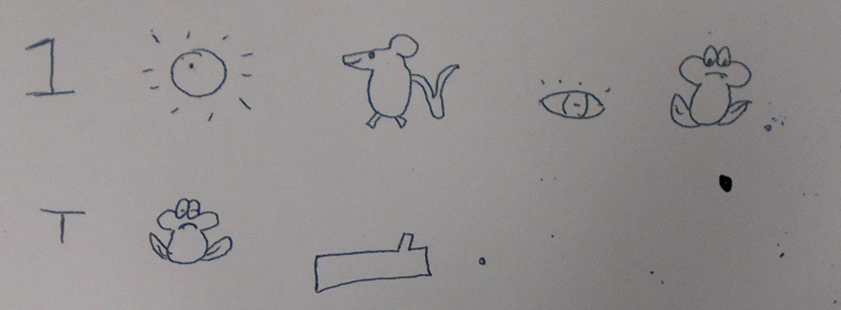  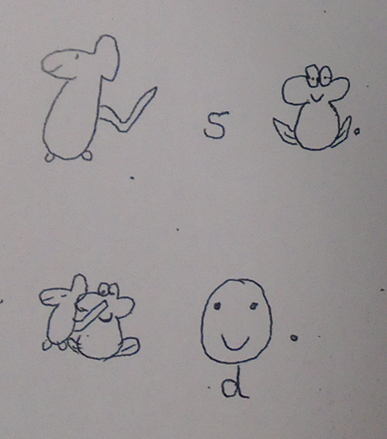  Here is the story, if you need help remembering.  One Sunny day the mouse met a frog.  The frog was stuck on a log.  The mouse saved the frog.  They were delighted.
I am learning to write a story | Now you know the story we are ready to write.  Give your children the story map to have next to them to help them write and remember the story. It’s important to say the sentence before they write it.  I would suggest 1 or two sentences a day so this make take 2 days.  Say the sentence Full stops CL Capital letters Finger spaces Robot arms  We have been using these prompts in class to help us remember the skills we use when we write sentences.
I am learning to plan my own story. | Our class have received a letter! Please read this letter to your child at home  Dear Year 1,  I have been a very helpful mouse helping all my friends and now they have helped other animals too but the author didn’t say how! Please can you help me write another part to the story to say how they helped each other?  From Harry the Happy Mouse.  The children will be planning a new story using the story map above.  Here is an example of my plan using the pictures and blank story plan below.  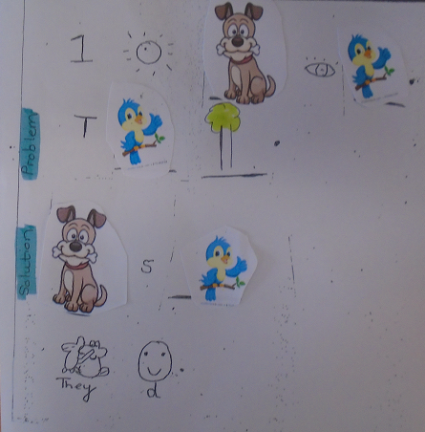  My story is:  One sunny day the dog met a bird.  The bird was stuck in a tree.  The dog saved the bird.  They were delighted.  Use the pictures and blank story map below to help the children plan their own story. They may want to draw the pictures and story map.  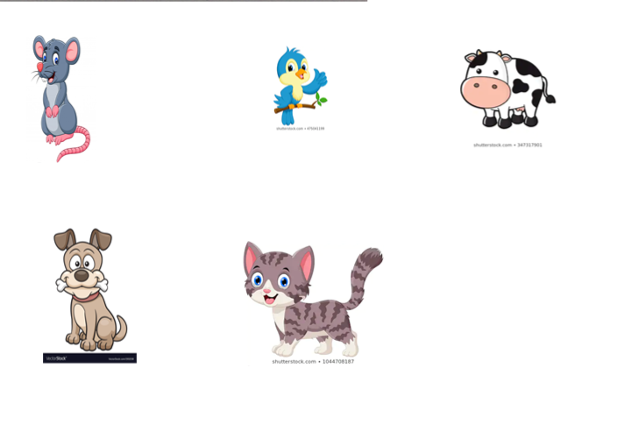  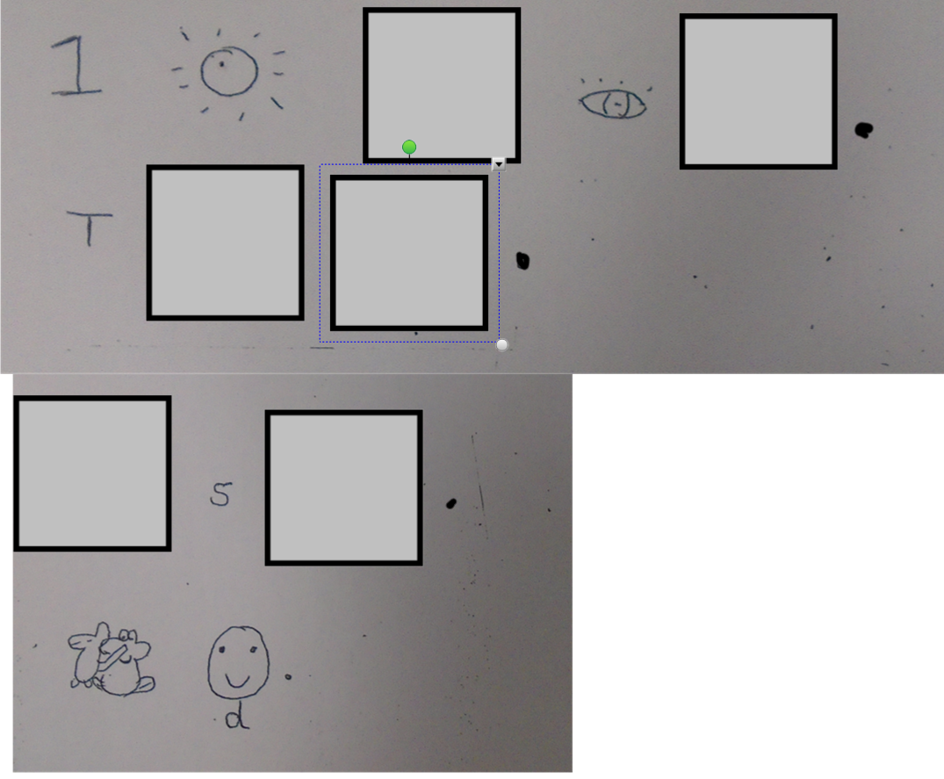
I am learning to orally retell my story. | Use the story map you created yesterday to retell your story. You might want to record your story and listen to it.
I am learning to write a story | Now the children have planned their own story map and orally said the story multiple times it is time to write the story.  Give your children the story map to have next to them to help them write and remember the story. It’s important to say the sentence before they write it.  I would suggest 1 or two sentences a day so this make take 2 days.  Say the sentence Full stops CL Capital letters Finger spaces Robot arms  We have been using these prompts in class to help us remember the skills we use when we write sentences.

History

In class we have been think about why the Fire of London spread so quickly. If your child needs help remembering why it spread so quickly please follow this link.

https://classroom.thenational.academy/lessons/how-did-the-great-fire-of-london-start-6mv62r?activity=video&step=2

Show your child a picture of the Monument in London. We have looked at this in class. The plaque has rubbed off over time. Ask your child to write a new plaque for the monument.

For example.

The Great fire of London spread fast because it started at night.
The Great fire of London spread fast because it was hot.
The Great fire of London spread fast because they had wooden houses.
The Great fire of London spread fast because they had thatched roofs.

Science

In science the children have been learning about plants and trees.

This lesson below looks at different types of trees; deciduous and evergreen

https://classroom.thenational.academy/lessons/what-is-the-difference-between-deciduous-and-evergreen-trees-c5j6ar

PSHCE
This week we are thinking and learning about our school value: Friendship

Read/Listen to the story Alone - from Days with Frog and Toad, by Arnold Lobel
https://www.youtube.com/watch?v=JQLs3u0wdfg

Talk about the story.
What is a friend?
How can we care about our friends?

Draw a picture of a special friend and write about why they like them.

