Home Learning – Science
Challenge: How many different types of species can you find that lay eggs?
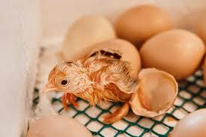
Watch this video to learn more about animals laying eggs:
https://www.bbc.co.uk/bitesize/clips/zdw9wmn

Now choose two different animals, making sure they are from two different animal groups e.g. bird and amphibian.
Can you discover what is similar and what is different about them? You can present this information in a way of your choice.
(Hint: a Venn Diagram might be useful! )

Home Learning – Art
This week in art we are going to create a 3D diorama of a scene from The Lion, The Witch and The Wardrobe.
These photograph might give you some good ideas:

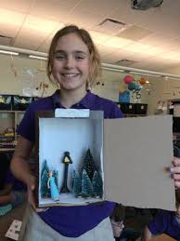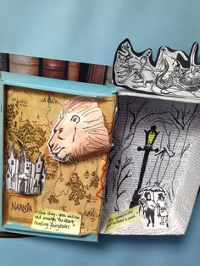
Home Learning – PE
We will continue to be focusing upon Netball and the following skills:
Throwing – Chest pass, Shoulder pass & Bounce pass.
Shooting – Holding the ball at the back and the side, bending knees and shooting in a steady line.
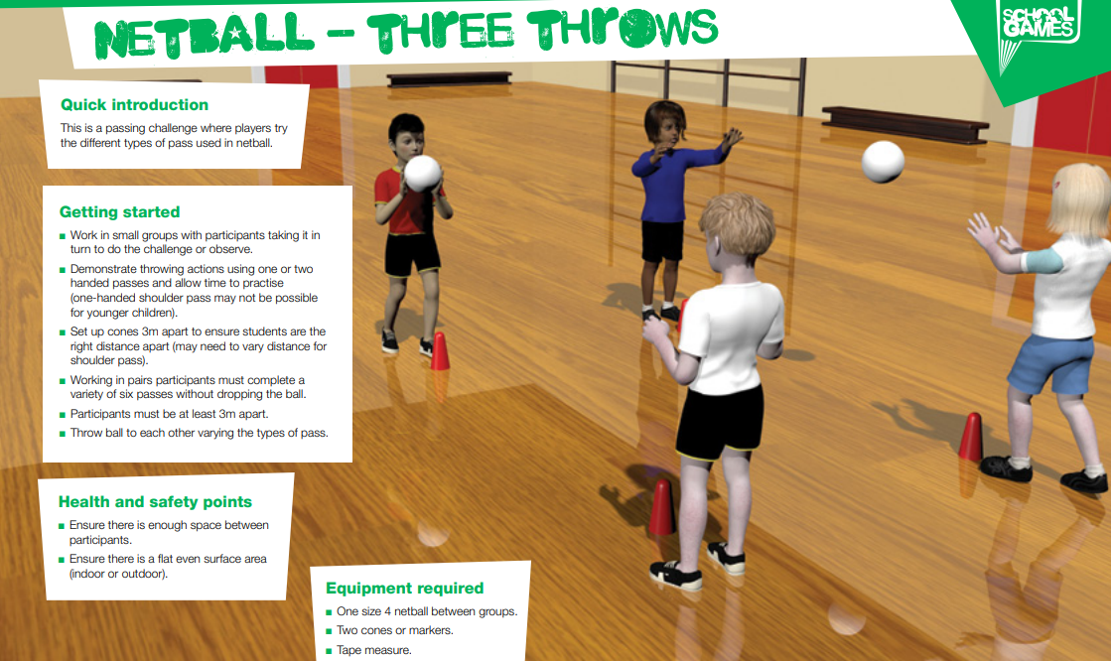
Let’s hope your ball has more bounce than the school ones!!

Home Learning – Computing
We will continue to be looking at online safety in class. Do you remember our task of creating a poster for a new APP you have designed?
Using a computer programme or paper, can you complete your APP poster? Remember to be persuasive, so I decide to download it and give my permission!
