Monday 12th October
Today we will be using our Picture News resources to explore what we can do to look after our world.

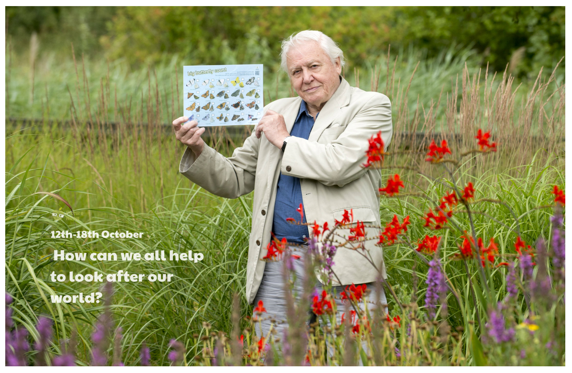

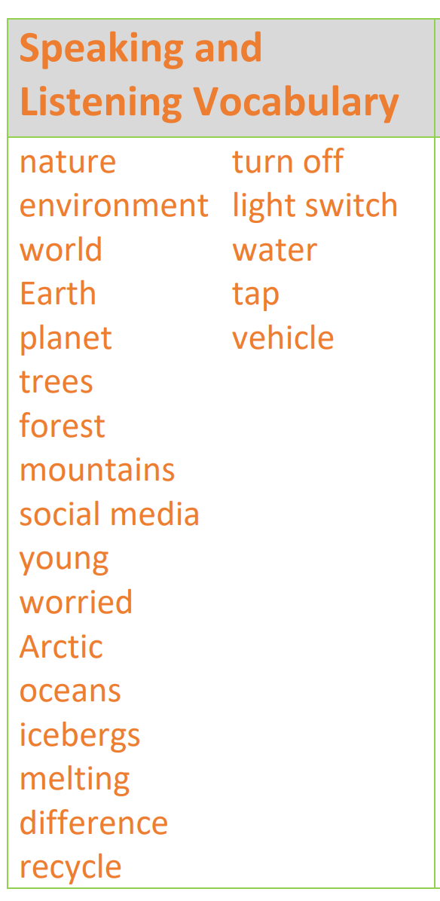
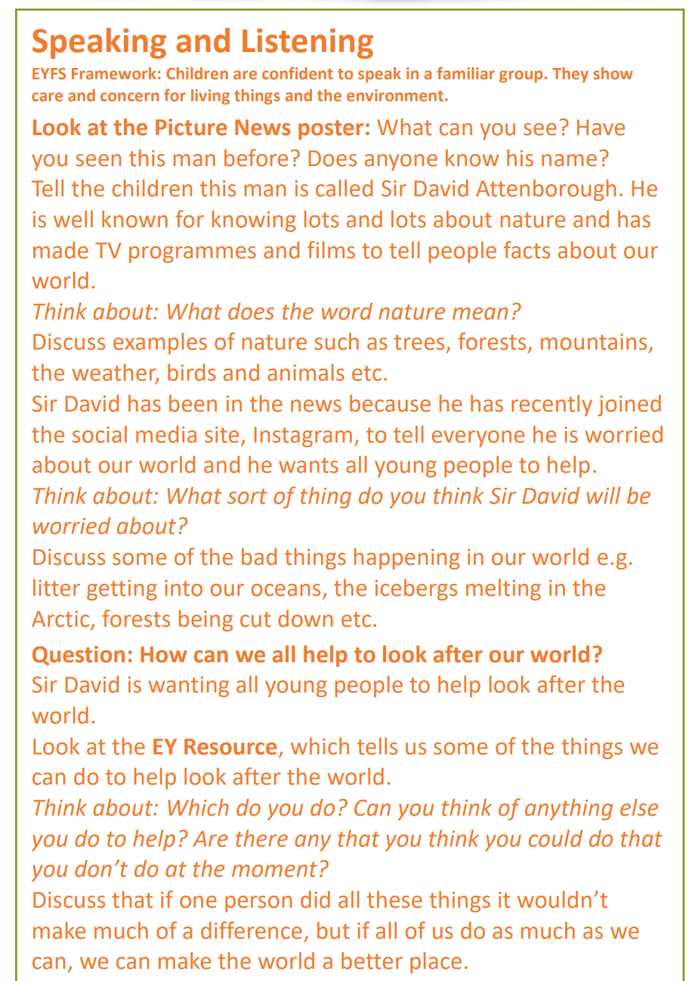
Please discuss the question in the box with your child. Use the vocabulary listed to support their language development. If your child does not know the meaning of a word, please explain it to them and revisit it throughout the week.
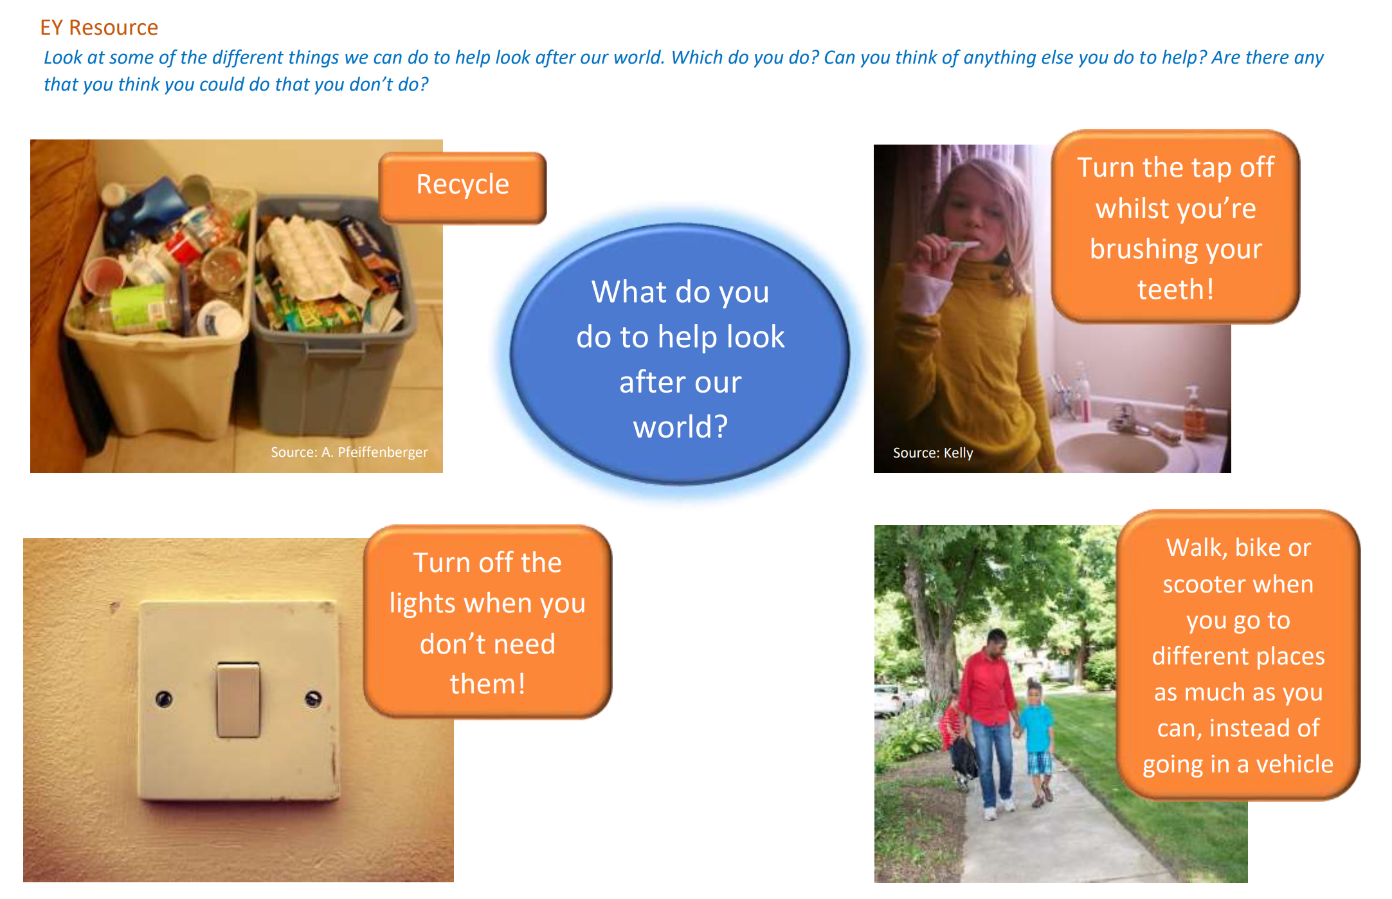

Can you make a poster to help explain to people how we can look after our world? You can send your posters to reception@moornook.lancs.sch.uk.

Phonics activity | Number activity | Shape activity
Letter of the day – d  The action to this sound is moving your hands like you’re playing the drums. Saying d d d d d.  Today’s activity is –  Find as many items in the house beginning with d.  Can you chop up the words dog and dig and write them?  Play eye spy with someone in your house .. listen to the initial sounds. | The Number of the week is 4.  Watch Numberblocks – Series 1 – Episode 4.  Today’s activity is -adding –  2+2= 4  3+1 = 4  Can you use objects at home to add together and say the number sentences above? | What is this shape?  Can you find this shape around your house?  How many sides does this shape have?  Practise drawing this shape.
Don’t forget to practise writing your name every day! This week’s spellings are on the website.

