LO: To understand the meaning of evergreen and deciduous trees.
This lesson we are continuing our work on deciduous and evergreen trees. Watch the videos below and complete the activity.
In Autumn, an evergreen tree looks like this… | In Autumn, a deciduous tree looks like this…
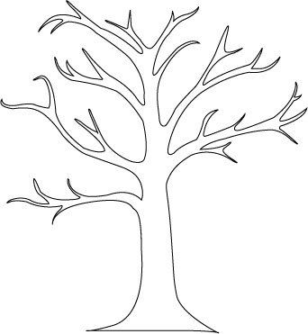

Link for home learning: https://www.youtube.com/watch?v=pMJ1KqZKF-k&safe=active https://www.youtube.com/watch?v=7h5TiPevd-Q&safe=active

