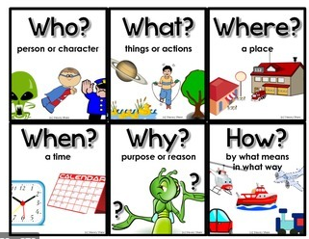
Friday 9th October
LO: To create facts about a fictional monster.
Using the monster you created and described
yesterday, and the question prompts
(Who, What, When, Where, Why and How) to help
you, try to come up with 10 interesting facts about your monster.

_________________________________________________________________
_________________________________________________________________
_________________________________________________________________
_________________________________________________________________
_________________________________________________________________
_________________________________________________________________
_________________________________________________________________
_________________________________________________________________
_________________________________________________________________
_________________________________________________________________
_________________________________________________________________
_________________________________________________________________
_________________________________________________________________
_________________________________________________________________
_________________________________________________________________
_________________________________________________________________
_________________________________________________________________
_________________________________________________________________

