Home Learning for Nursery
Week commencing: 19^{h} October 2020 | Maths-Now that you have learnt how to sort socks into  pairs and sort cutlery into sets-this week we are going to learn about pattern.  Topic-‘Marvellous Me’. We have been learning lots of things about ourselves.
Monday  Communication and Language  Literacy  Phonics | Collect five items and talk about them e.g. a cup, a pencil, a coat, a bag and a pair of shoes. What do we use a cup for? Why do we wear shoes? Can you tell an adult what the other items are used for?  Challenge- can you draw a picture of one of the items?  Practise singing nursery rhymes! This week in nursery we will be giving out certificates for those children who can sing three nursery rhymes.  Come on children you can do the ‘3 rhyme challenge’. Good luck everyone!  In phonics we have been learning how to be a good listener. Sitting smart, looking eyes and listening ears!  With an adult complete one of the activities form the Home Learning Challenge-General Sound Discrimination-Body Percussion.
Tuesday  Maths | Please see link for-Pattern Fish story. This is a lovely story for introducing your child to pattern.  https://www.youtube.com/watch?v=7_mqVCewsYA  Click on the link below to watch the video: Patterns and Colours Children's Song | Green Orange Shapes Patterns | Patty Shukla  https://www.youtube.com/watch?v=PxGEcfyD49U  Now can you tell an adult what the two AB patterns are below?  Red circle, blue circle, red circle, blue circle, verbalising the pattern helps.  Green circle, yellow circle, green circle, yellow circle and so on. You could ask your child what would come next to continue the pattern.  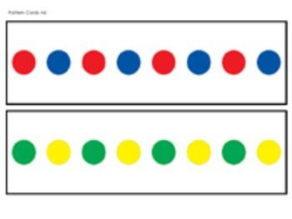  Challenge - can you draw an AB pattern like the one above using two colours?
 | You can email any work your child has completed to nursery@moornook.lancs.sch.uk

