Create some expanded noun phrases about this picture
e.g. long, skinny legs with knobbly knees
tall, green trees with whispering leaves

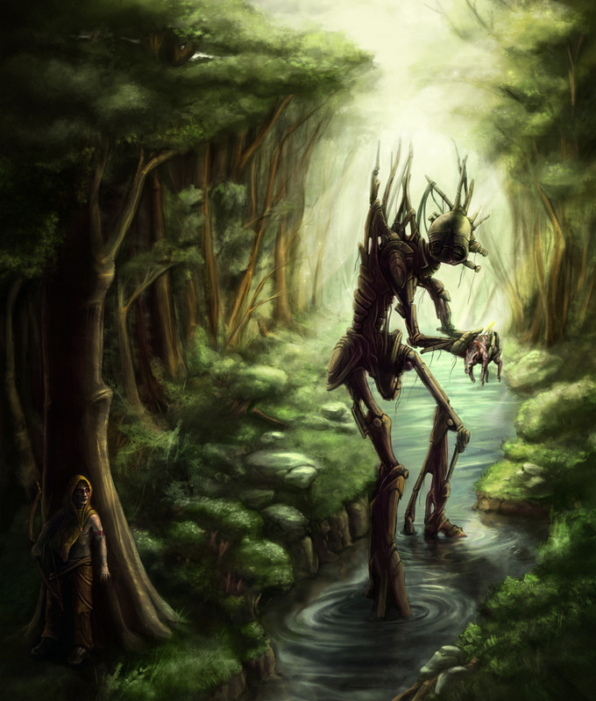

Describe the setting using the expanded noun phrases you have created.

