Monday 19th October
Today we will be learning about rhyming. Sing your favourite Nursery Rhyme. Can you spot the rhyming words?
https://www.bbc.co.uk/cbeebies/curations/nursery-rhymes

Challenge – Can you continue the rhyming strings – you could use your phonics to help you spell the words.
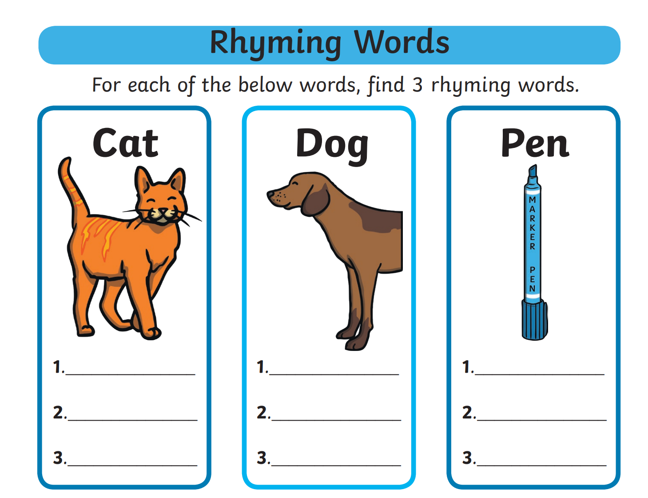

Activity – Play the game – Washing line rhyme – Remember to listen to the sounds carefully.
http://www.literactive.com/Download/live.asp?swf=story_files/washing_line_rhyme_US.swf

Don’t forget to practise writing your name every day! This week’s spellings are on the website.

Phonics activity | Number activity | Shape activity
Today I would like you to play the game – cross the river.  Put a blanket or cushions on the floor and this will be your river. You have to read the sounds/words in the river to be able to cross.  Please use the sounds and words below.  s a  t p  Pin Tap  Sit Tin  pat the  You can make more words using the sounds learnt over the past week. | The Number of the week is 5.  Watch Numberblocks – Series 1 – Number 5.  Today’s activity is 1 less. Collect 5 items from around your house then take 1 object away each time and count how many are left. Practise saying the sentence – 1 less than 5 is …. 1 less than 4 is …. Etc. | What is this shape?  Can you find this shape around your house?  How many sides does this shape have?  Practise drawing this shape.
Here is your first 50 experiences before you’re 5 – you can email the photos to reception@moornook.lancs.sch.uk.
50 experiences before you’re 5
This week’s experience is . . . .
Jump in autumn leaves

