LO: To label a shrine in a Mandir (temple).
For this lesson we will look at a video of a shrine in the temple and a shrine in the home. Write down things that are the same and things that are different.
https://www.youtube.com/watch?v=o-s0mN5P8jo&safe=active – Temple
Can you spot any other items you know from last week’s lesson on Puja?
https://www.bbc.co.uk/bitesize/clips/zh2hyrd - Home shrine
Remember Murtis is the deites image (God) that the person has chosen to worship.

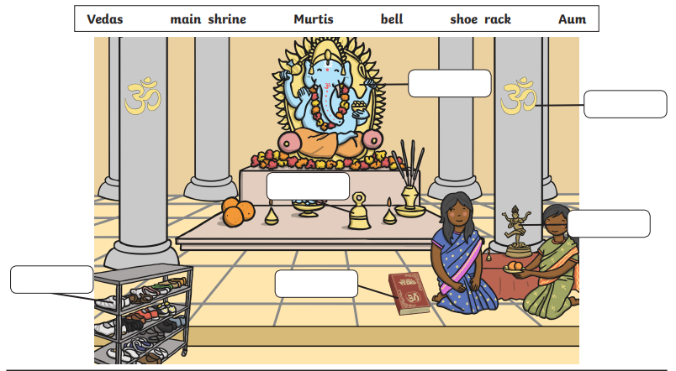

LO: To compare shrines at home and shrines in a temple. | Shrine at a temple | Shrine in a home
 | 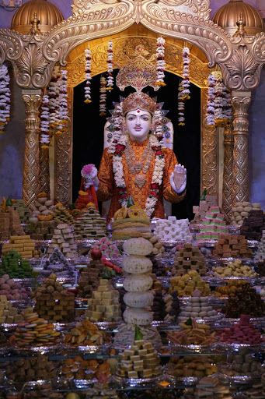 | 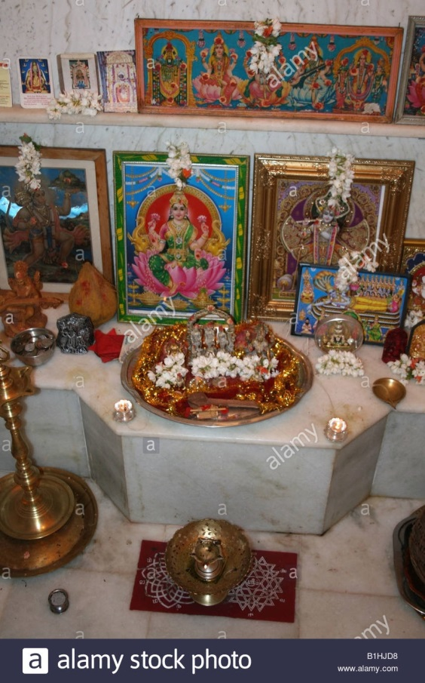
Similarities
Differences

