Morning Year 6,
I have done you a timetable for the week. The resources that you need are below the timetable. These can either be written on paper or typed on a computer. Have a good week, we miss you. Miss Coar.
Thursday | English  LO: To use ‘ing’ opening clauses to write the beginning of their story.  To write the beginning of your story using your plan from this week and your ideas from gathering the content from the videos yesterday.  Think about other writing skills you have learnt…  Fronted adverbials  Ing openers  Noun phrases | Maths  LO: To multiply a 4 digit number by a 2 digit number  Start with your timestable sheet (attached on the website) and time yourself to see how long it takes you. Try to beat your time each day.  Main lesson:  Use the formal method (column multiplication) to work out the calculations. Try to work on your accuracy today. | Science:  LO: To describe how living things are classified into broad groups according to common observable characteristics and based on similarities and differences  Recap the 5 animal groups (fish, amphibians, reptiles, bird and mammals) by researching what their characteristics are.  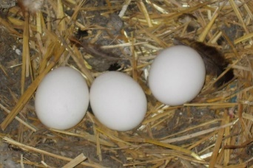  Look at different images of the platypus online and discuss which features would put it into different groups  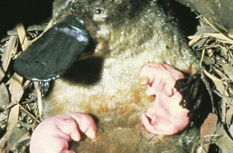  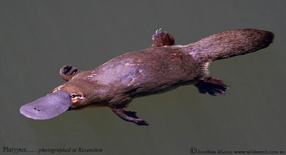  Example  It’s got hair like a mammal. It’s got webbed feet like a duck and a funny flat beak. That means it’s a bit like a bird. Are those babies sucking milk? That’s like mammals. Hold on, if it’s a mammal it shouldn’t lay eggs.
Friday | LO: To blend action, description and dialogue.  Use your planning grid to write the next section on your plan.  This is the section where the main character is chased by bullies from the orphanage and they enter a shop.  Think back to when you wrote a diary entry for this, you may be able to use some of your descriptive ideas to describe the chase through the streets. | Maths  LO: To multiply a one-digit number with up to 2 decimal places by a single digit by using a columnar method  Start with your timestable sheet (attached on the website) and time yourself to see how long it takes you. Try to beat your time each day.  Main lesson:  Use the formal method (column multiplication) to work out the calculations.  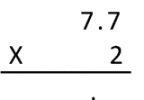  You set these out exactly the same as a multiplication with whole numbers…  It would also be the same layout for a decimal with two places…  7.77  x 6 | Science:  LO: To describe how living things are classified into broad groups according to common observable characteristics and based on similarities and differences  Today, you are going to create your own imaginary animal, giving their key features and explaining which group they would best fit into.  See below for an example.  